**ANL 488 PROJECT PROPOSAL**

Evaluating Clustering Algorithms for Prediction of Rock Type

for Mining Oil, and Gas across Different Geographies



**Submitted by**

Tan Wen Xuan

**SCHOOL OF BUSINESS**

**Singapore University of Social Sciences**

**Presented to Singapore University of Social Sciences**

**in partial fulfilment of the requirements for the**

**Degree of Bachelor of Science**

**In Business Analytics**

2022

**TABLE OF CONTENTS**

**Chapter 1: Introduction** 4

**Chapter 2: Literature Review** 7

**Chapter 2.1: Traditional Rock Typing** 7

**Chapter 2.2: Rock Typing utilizing machine learning** 8

**Chapter 2.3: Rock typing – machine learning approach** 10

**Chapter 2.4: Comparative study of clustering algorithms** 11

**Chapter 2.5: Literature Conclusion** 12

**Chapter 3: Data Understanding and Initial Preparation** 13

**Chapter 3.1: Datasets Overview** 13

**Chapter 3.2: Datasets Preparation** 13

**Chapter 3.2.1: Africa** 14

**Chapter 3.2.2: UK** 19

**Chapter 3.3: Data Understanding** 21

**Chapter 3.3.1: Africa** 22

**Chapter 3.4: Data Preparation** 26

**Chapter 4: Proposed Modelling and Evaluation** 27

**Chapter 4.1: Proposed Modelling** 27

**Chapter 4.2: Evaluation** 28

**Chapter 5: Proposed Schedule** 28

**References** 29

**Appendix A** 32

**A.1: Africa** 32

**A.2: Australia** 34

**A.3: Brazil** 39

**A.4: China** 40

**A.5: Myanmar** 41

**A.6: North Sea** 43

**A.7: Philippines** 44

**A.8: Pakistan** 45

**A.9: Papua New Guinea** 46

**A.10: United Kingdom** 48

**A.11: United States of America** 50

**Appendix B** 52

**B.1: Africa** 52

**B.2: Australia** 54

**B.3: Brazil** 56

**B.4: China** 59

**B.5: Myanmar** 61

**B.6: North Sea** 63

**B.7: Philippines** 66

**B.8: Pakistan** 68

**B.9: Papua New Guinea** 69

**B.10: United Kingdom** 71

**B.11: United States of America** 74

# **Chapter 1: Introduction**

Rock typing is the characterization of reservoir rocks into similar groups that are petrophysical similar (Hollis et. al., 2020). Much research has been done on rock typing reservoir rocks of reservoirs for determining optimal rock types for drilling. Those studies typically consist of the application of indices like FZI or FZI* onto data that uses additional data alongside core data like well logs data. For example, the study by Mirzaei-Paiaman et. al. (2020) presented a new framework (GHE) and in their study data used was using the RCAL data.

One of the main sources of oil and gas is from drilling wells in sedimentary basins that are of sandstone or carbonates (*National Geographic*, n.d.). Sedimentary basins are areas of the earth’s crust that have been underlaid under thick layers of sedimentary rocks, whereby the thickness of the rocks exceeds a certain threshold (*Sedimentary Basin*, n.d.). Although there isn’t a clear number for that thickness, 100 km length and width of 10 km would be a suitable threshold (*Sedimentary Basin*, n.d.).

Oil and gas are then produced from these basins by drilling a well. The primary recovery process is as follows, it would firstly be the fitting of tubes and casing pipes for the transportation of hydrocarbons (Dutta, 2022). Once the well is tapped, the hydrocarbons are extracted and transferred to the surface for processing (Dutta, 2022). From there, filtering of the mixture of water, oil, and gas to their separate components is next, and then finally the oil and gas are treated and purified after removing the water (Dutta, 2022).

Before the production phase of oil and gas, when the well is first drilled, rock samples are extracted to determine the flow capacities and storage. In the current context, flow capacity refers to permeability which is a characteristic that describes the flow capacity of rock while storage refers to porosity, which is the characteristic describing the storage amount of the rock that holds the oil/gas (Geomore, n.d.). The two are important characteristics that are used for determining rock types.

For determining unique rock types, we must first rock type. Rock typing is the assignment of reservoir rocks to distinct geological facies (Tavakoli, 2018). Rock typing would give us knowledge of the different rock types in the well, aiding in the planning of drilling based on “optimum” rock type.

Machine learning is a subset of artificial intelligence, it utilizes data and algorithms to learn like humans and to improve the acracy through learning (IBM Cloud Education, 2020). It can make predictions and classifications based on input data, labeled or not, to produce a prediction or classification from the data (IBM Cloud Education, 2020). Optimization can be made on the models to improve the result of any algorithm (IBM Cloud Education, 2020). There are three types of machine learning, Supervised, Unsupervised, and Semi-supervised (IBM Cloud Education, 2020). Supervised machine learning uses algorithms on labeled datasets to classify and predict outputs, Unsupervised machine learning uses algorithms on unlabeled datasets to cluster the datasets into unique groups, and Semi-supervised machine learning uses both labeled and unlabeled data to train algorithms (IBM Cloud Education, 2020).

In the area of rock typing, the studies mostly use rock typing indices on a variety of data to rock type. There have been studies where machine learning has been applied in their methodology to rock type while using indices. Some studies even explore rock typing using machine learning without indices. However, such studies mostly use supervised machine learning and a mixture of data which may be costly to acquire. Using unsupervised learning on only core data is something that has not been researched extensively and hence there is value in focusing on the area.

In this project, we would be using different unsupervised machine learning clustering methods to perform rock typing on publicly available datasets from different regions and then evaluate which model is the best. The algorithms selected are K-Means, Centroid Neural Network, DBSCAN, BIRCH, and Gaussian Mixture models. The project objective would be to evaluate which clustering models would have the best performance in rock typing on core data of eleven regions. The data used for this project include Africa, Australia, Brazil, Myanmar, Pakistan, Papua New Guinea (PNG), the UK, China, the North Sea, the Philippines, and the USA. With these data, we will be performing rock typing using multiple clustering models and after that evaluation of models will be done.

The proposal report format will be as follows: Introduction, Lit Review, Data Understanding, and Preparation, Proposed Modelling and Evaluation, and Proposed Schedule.

# **Chapter 2: Literature Review**

## **Chapter 2.1: Traditional Rock Typing**

Previous and prevalent approaches to rock typing revolve around the usage of rock typing indices on core, well logs, and other data (Special Core Analysis Laboratory (SCAL  
)). Common indices that are used are the FZI, FZI*, and FZIM (Mohammadian, 2022). In most of the literature available on rock typing, rock typing indices are used in their methodology alongside different methods each literature proposed. The following are some examples of studies using rock typing indices as part of their approach for rock typing.

Faramarzi-Palanga and Mirzaei-Paiaman (2021) used rock type indices to determine flow for dynamic rock typing where in dynamic rock typing, fluid flow traits are critical for dynamic rock typing. They used the FZI, FZI*, FZIM, and MFZI indices which are slight variations of one another on SCAL data (Faramarzi-Palanga & Mirzaei-Paiaman, 2021). The performance of the indices was then compared using the (True Effective Mobility) TEM technique, which the TEM technique is a criterion for determining dynamic rock types (Faramarzi-Palanga & Mirzaei-Paiaman, 2021). The results of the study showed that the FZI* performance was superior to the other three indices for both water and oil saturation and that FZI was better performing than MFZI and FZIM (Faramarzi-Palanga & Mirzaei-Paiaman, 2021). The study concluded that the additional parameters of the different indices can be complex, but it does not necessarily equate to superior performance or even improve applicability (Faramarzi-Palanga & Mirzaei-Paiaman, 2021). In this study, four indices were selected and applied to SCAL data to compare with the TEM function to derive the performance of the indices, the indices were the focus of the study for rock typing.

Shahat et. al. (2021) proposed a new rock typing approach using well-log data. In their study, they proposed the Resistivity Zone Index (RZI) used on well logs data for enhancement in rock typing. The performance of this approach was compared to other approaches using the same data. The conclusion was that the technique had high accuracy.

Soleymanzadeh et. al. (2019) explores changes to rock typing using the FZI*, FZI, and Winland method when pressure is varied. The permeability and porosity values of the core samples were measured for five various pressure and the three indices were applied using those values. The goal of the study was to study how pressure affects rock typing and with the application of indices being the method of rock typing.

In the above-mentioned studies mentioned, we can see that the rock typing studies included rock typing indices as part of their methodology for their studies. The indices require different parameters to be available for the calculation of the index for rock typing. This is true for many rock typing studies previously done. This is a limitation due to differences between datasets like core and well data or even between two different wells. For a given index, it may not apply to different datasets if a particular required parameter is not available. The inflexibility of applying a rock typing approach to a different dataset is a disadvantage for rock trying.

## **Chapter 2.2: Rock Typing utilizing machine learning**

Rock typing studies in recent years have explored rock typing with machine learning models, both supervised and unsupervised algorithms. It is not very well explored, and those studies mostly focus on the supervised models. Usage of machine learning can bring about high accuracy of rock typing whiles bringing flexibility as algorithms can easily be used for different data as compared to rock typing using rock type indices. The following studies show the use of machine learning for rock typing.

In Mohammadian et. al. (2022), rock typing was done using a modified rock typing index (FZIM*) together with supervised and unsupervised machine learning algorithms. The data used was the core data consisting of four properties which are permeability, porosity, connate water saturation, and pore throat radius with 35% mercury injection (Mohammadian et. al., 2022). In the study, the data was used to train a supervised algorithm, the Extreme Gradient Boosting (XGB) with FZI index values which were calculated from the data set as a target to get the FZIM* as the output. The FZIM* was then used with k-means clustering to determine the ideal number of rock types based on the dataset. The study talks about four deployments and one of which was on rock typing. For the rock typing deployment, the performance of the method was compared to two other approaches of rock typing using indices, the FZI and FZI*. The proposed method of combining machine learning for rock typing in this study had a better performance than the other two methods that were used to compare. From the study, we can see the inclusion of machine learning for rock typing in this study has indeed brought about better rock typing accuracy. However, the limitation to this approach is still the complexity of using indices-based approaches due to the harsh requirements of data needed.

Zakyan et. al. (2022) proposed an enhanced method of clay typing in their study. They performed rock typing with log data using an artificial neural network (ANN) algorithm as part of the proposed enhanced method of clay typing. The artificial neural network was used in their approach integrated with other non-machine learning methods. The result of their study was the development of the enhanced clay typing approach. A limitation of this study is that the method can only be used for log data.

In both the studies above, machine learning has been integrated and applied with their other methods that require certain data to be available for their approaches. The limitation of needing certain data makes rock typing for those methods complex as the methods would only be applicable for specific kinds of data. Machine learning models in the studies were utilized to bring improvements to rock typing altogether.

Many rock typing studies use rock typing indices for rock typing, which can be considered the traditional and prevalent approach in rock typing. In some newer studies, machine learning has been integrated with rock typing indices for improvements to rock typing. The use of indices is very complex due to the many variations of indices and the restrictions on the type of data needed. Rock typing solely on machine learning has not been widely studied and they may have good performance of accuracy even if rock typing indices were not used. The approach would be more flexible in terms of data requirements, and this may be beneficial and more efficient for rock typing.

## **Chapter 2.3: Rock typing – machine learning approach**

Although there are rock typing studies that utilized machine learning in their approaches, studies of rock typing that solely use machine learning are not widely researched.

In Mohamed et. al. (2019), rock typing was done using supervised and unsupervised machine learning algorithms. The well-logs data was split to train and test set before training of machine learning models. A total of five algorithms were used in the study for comparison and evaluation of each method for rock typing. The methods used are KNN, SVM, Random Forest, Neural Network, and K-means, three supervised and two unsupervised algorithms. Grid search was applied for optimization of parameters for the models and evaluations are based on precision, F1, recall, and accuracy. The result of the study was that the supervised algorithms which are KNN, SVM, and Random Forest had better performance than the other two algorithms followed by neural network and lastly, k-means with parameters optimized.

In the study, more supervised algorithms were used than unsupervised algorithms. The advantage of using machine learning to rock type without the need for rock typing indices is that the models can easily be applied to any dataset. For supervised algorithms, to rock type, the rock type must first be identified in the training dataset for the algorithm to be able to classify rock types. This can be a challenge especially when rock type is not available. Unsupervised learning however does not require the dataset to know the rock type before training. The algorithm would be able to cluster data with similar characteristics together to form rock types. Although the unsupervised method had poorer performance than supervised methods, supervised methods require data to already be rock typed to use the methods. Unsupervised methods, however, do not have such needs and thus have greater flexibility and applicability.

## **Chapter 2.4: Comparative study of clustering algorithms**

In the area of rock typing, rock typing with machine learning is not a well-studied area, especially so for unsupervised machine learning. In most rock typing studies that included machine learning, supervised learning was more utilized. Even in Mohamed et. al. (2019), amongst the five machine learning algorithms, there were more supervised compared to unsupervised algorithms.

Rodriguez et. al. (2019) compared 9 popular clustering algorithms in their study with a systematic approach using artificial datasets with varied properties, like the number of classes and number of features. Comparisons of model performances were done through the usage of three methodologies, which are (1) performances of models with default parameters (2) one-dimension analysis, and (3) multi-dimension analysis. The first method is training the models with no adjustment to their parameters. The second method is training models with one parameter varied and the last method is a simultaneous adjustment to all parameters. The result of the study was the comparison of the performance of all 9 clustering algorithms of the three methodologies.

The similarity between this study and our own would be the application of multiple clustering algorithms on a set of data. In this study, they took on three approaches to evaluate the nine algorithms’ performance in each approach. For our study, our focus would be on optimizing the performance of each algorithm while variating algorithm parameters, which was the direction of this study. We will not however be using different approaches to compare performance on separate approaches.

## **Chapter 2.5: Literature Conclusion**

As seen from the literature reviews, rock typing mostly has been using rock typing indices to rock type. In several of the studies, machine learning has been introduced as part of their methodology to enhance rock typing. Rock typing with indices is limited due to the requirements of data for different indices which rock typing using machine learning can solve. In a study mentioned above, rock typing was done using five machine learning algorithms. In that study, the supervised algorithms had better performances than unsupervised algorithms. Supervised algorithms require the dataset to be labeled before training. In the context of rock typing, it would mean that the dataset would have to have the rock types for the data to be able to use supervised machine learning. This can be inefficient and impractical when it comes to rock typing due to the many differences in different data and types of data.

The study of rock typing using clustering approaches has not been studied enough and should be explored further as unsupervised machine learning does not require datasets to know the rock types of the data. In our study, we will be evaluating different clustering algorithms on core data for different regions.

# **Chapter 3: Data Understanding and Initial Preparation**

## **Chapter 3.1: Datasets Overview**

In our study, we are using publicly available datasets for eleven regions to train on unsupervised algorithms and then compare. The datasets will have to first be prepared as many of the regions’ data comes in separate files. We merged the data and did an initial selection of columns based on the number of empty values in each row and the meaning of each column. We remove columns that are redundant and would likely not be useful. This step would combine the many files until we have eleven separate datasets representing the eleven regions. We then do exploratory data analysis on the datasets to study and follow up with cleaning and preparation of the dataset. Exploratory data analysis, cleaning, and secondary preparation will take place concurrently to ensure the data is ready for modeling.

## **Chapter 3.2: Datasets Preparation**

A total of eleven core datasets are used in this study and are retrieved from the following sources: [(Data Underground, n.d.), (GeoProvider, n.d.), (UK National Data Repository, n.d.)]. The regions are Africa, Australia, Brazil, Myanmar, North Sea, Pakistan, Papua New Guinea (PNG), UK, USA, China, and the Philippines.

Before data understanding, merging of dataset and selection of appropriate columns must be done due to the number of files there are and, in some datasets, the number of columns there are. Moreover, the majority of the data’s column and rows in most files is empty and is not useful. Hence it is important to refine the dataset before moving on to data understanding and cleaning. The steps for the 11 datasets are mostly similar with slight differences depending on the number of files, columns, and data structure each of the files for each region contains. A brief walk-through of the preliminary preparation will be done using two regions. The steps for all the eleven regions are available in **Appendix A**.

Before doing the initial dataset preparation, the following libraries were imported.

**Figure 1**

Importing of libraries

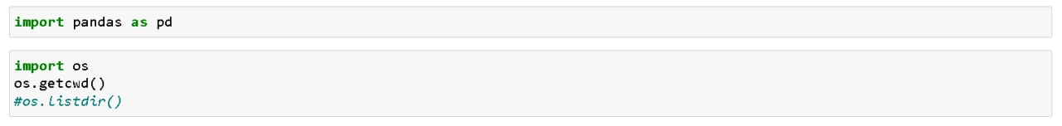

The data cleaning process for Africa and UK will be shared below. For the rest of the regions, the process is similar.

### **Chapter 3.2.1: Africa**

There are two workbooks for Africa, and it contains many columns with many rows. The following codes were used to refine the data and merge the two files.

**Figure 2**

Africa Dataset Preparation Part 1

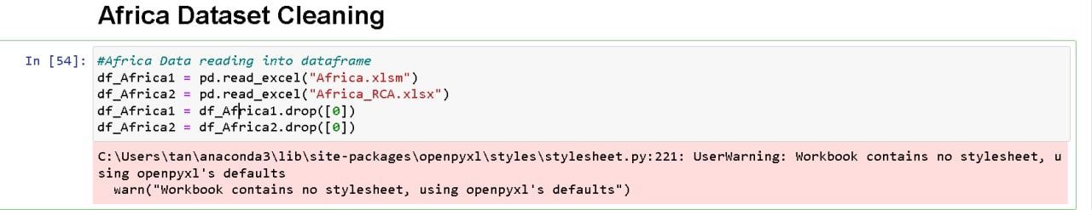

The two files loaded onto python using pd.read_excel and into separate DataFrames. The head() function is then used on each DataFrames and the result is then printed out. The function returns the first n rows, the default n is 5 if no n parameter is passed. It would also show the total number of columns present in the DataFrames. The following codes show how it was applied to the two Africa files.

**Figure 3**

Africa Dataset Preparation Part 2

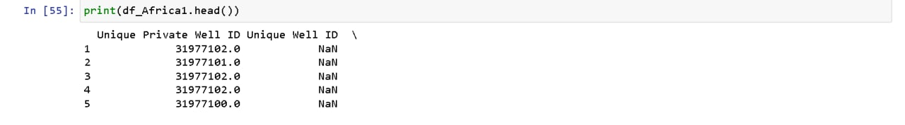

**Figure 4**

Africa Dataset Preparation Part 3

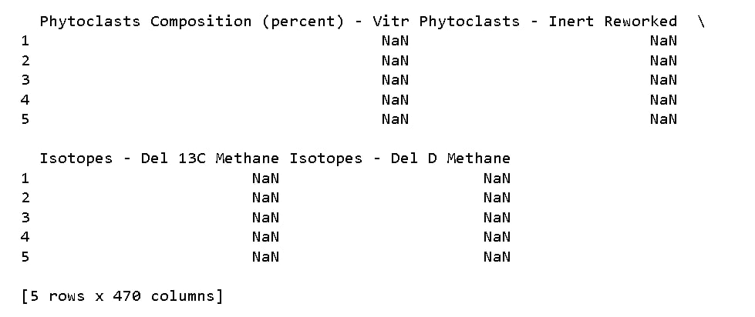

**Figure 5**

Africa Dataset Preparation Part 4

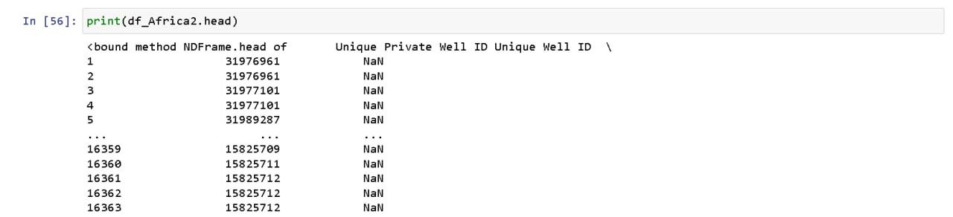

**Figure 6**

Africa Dataset Preparation Part 5

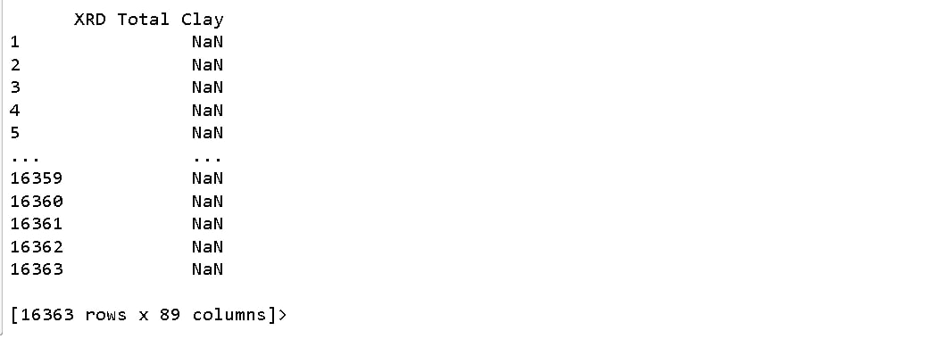

From the two DataFrames head() function output, we can observe the total number of columns, and if within the first five rows, there are rows that should be dropped. Such rows were removed via the drop method as shown in figure x as it was describing the formatting of the columns.

Next, I print a list of each of the DataFrames of each file as shown in the figure below.

**Figure 7**

Africa Dataset Preparation Part 6

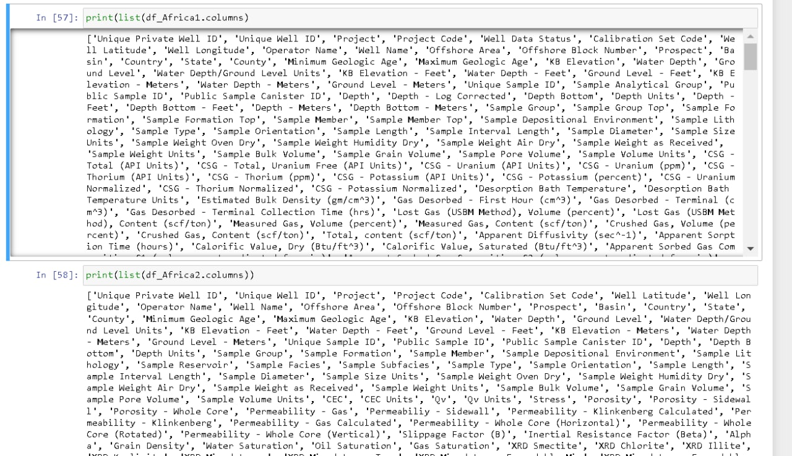

For Africa, there were too many columns to have any use to view the column names using this method. A combination of using this method and manually viewing the excel files was used to decide which columns to keep. Taking note of what each column show plays a part in deciding what to be kept as well as the number of non-null data in each column. The null values were viewed using the following codes.

**Figure 8**

Africa Dataset Preparation Part 7

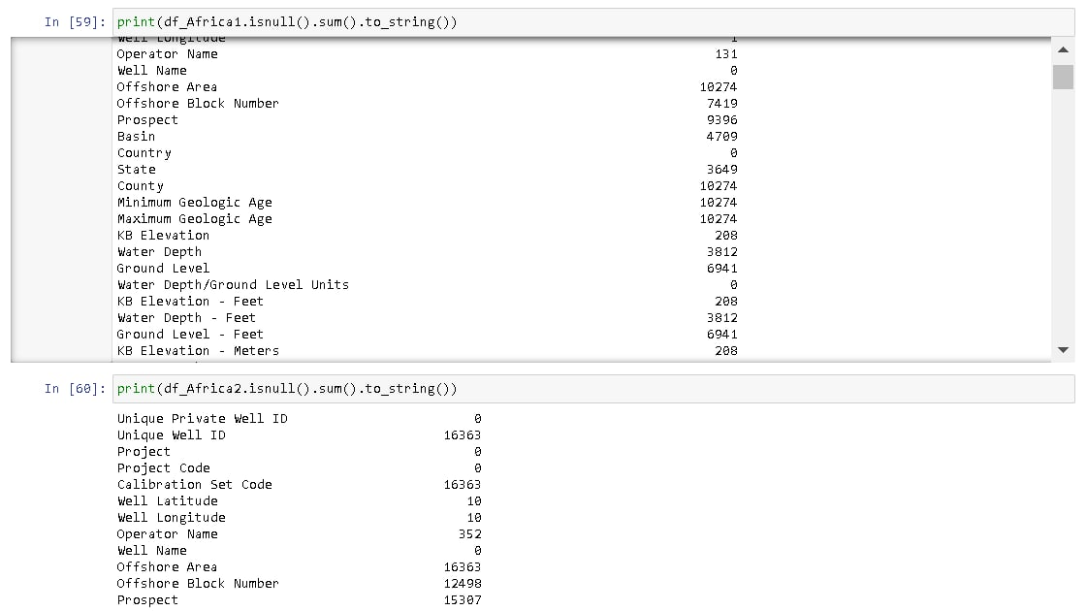

This helps with the deciding of columns to be kept if the number of empty rows is too high relative to the number of available data which can be seen from the excels themselves, there would be no meaning to keep them for the training of models.

The DataFrames columns were then standardized for both DataFrames as seen in fig x below and the two DataFrames are then combined into a single DataFrame as seen in fig x below. The DataFrame columns were first chosen before being renamed and combined using the pd.concat() method.

**Figure 9**

Africa Dataset Preparation Part 8

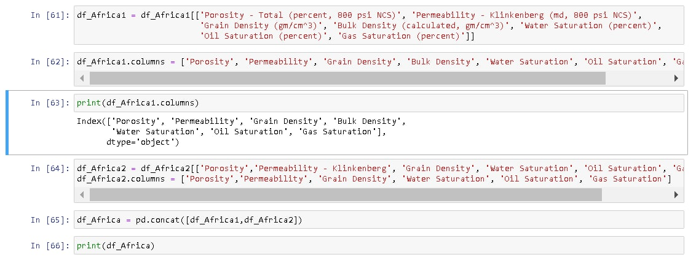

The number of rows and columns of the final DataFrame was checked using the shape() function. Null rows are then checked again before writing the DataFrame into the computer as a CSV. At this point, the preprocessing of the data for Africa is done.

**Figure 10**

Africa Dataset Preparation Part 9

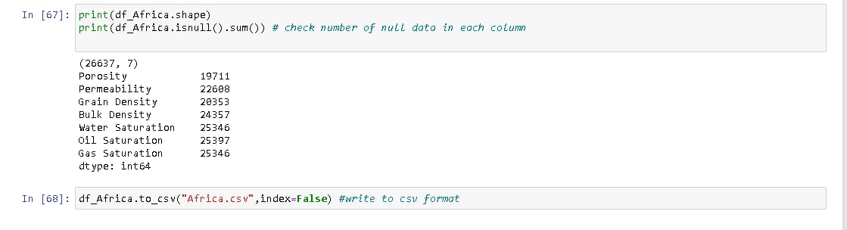

Further cleaning would be done after data understanding. The steps shown above are similar across all other region’s data except for the UK which will be shown below.

### **Chapter 3.2.2: UK**

For the UK dataset, there were close to two thousand files that needs to be merged. The format of the column was similar. To merge the data into one data, there was a need to shift subfolder files all into a single location before running a code to merge the data. The codes used for moving files are shown below.

**Figure 11**

UK Dataset Preparation Part 1

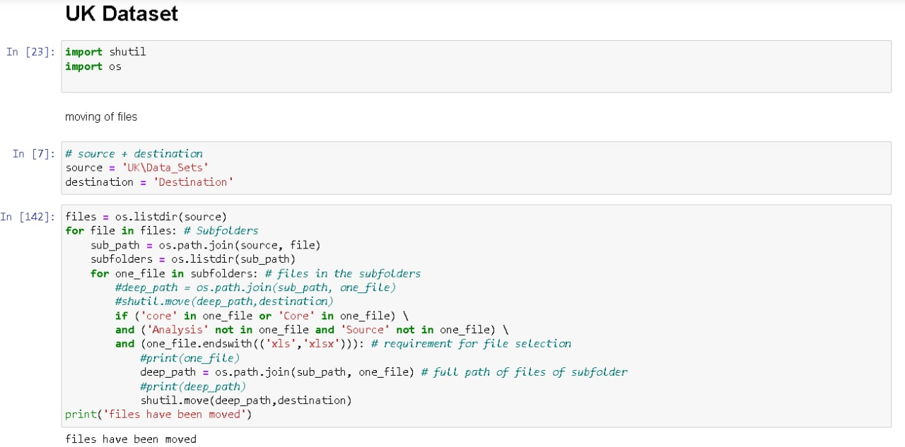

The source and destination files were stated to set the location where the files are retrieved and where it is to be saved. os.listdir(source) was used to store the subfolder names that are in the source. A loop and inner loop were then coded to assess the individual files that are of a certain naming convention and type. Those files were then moved to the preset destination. After the files that met the conditions were gathered in a single folder, it was then merged using the following codes. The .xls and .xlsx were separately merged due to importing method differences. Corrupted files were also removed with constant trial and error.

**Figure 12**

UK Dataset Preparation Part 2

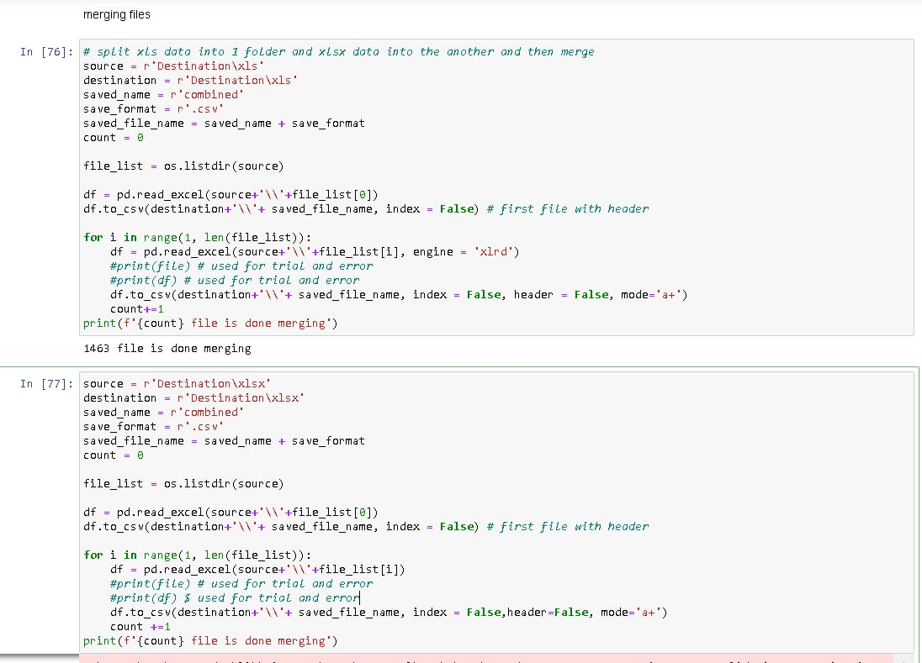 The result of the codes above is two CSV files. The two files are moved to another folder by themselves before the execution of codes to merge them as seen in the next figure. The two merged files are saved in CSV format the two were combined into a single CSV file.

**Figure 13**

UK Dataset Preparation Part 3

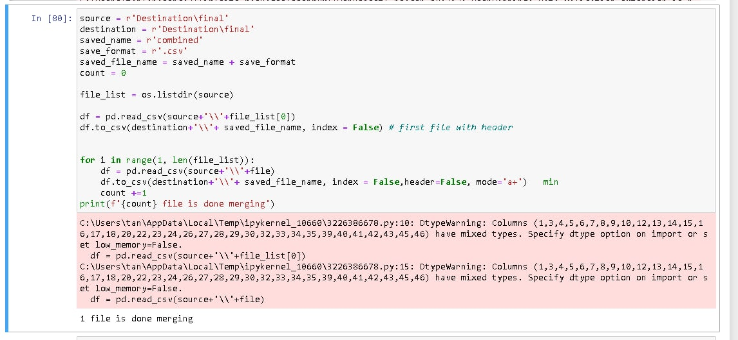

The final CSV file is checked for the number of null values in each column, selection of columns, checking of the number of rows and columns, and then saved the file. The steps for those steps are like the Africa data cleaning steps.

Overall, the steps for preparing the data for the eleven regions vary from one another but the process is very similar to the steps shown for the Africa dataset preparation. Following the data preparation, we can then move on to data understanding.

## **Chapter 3.3: Data Understanding**

For data understanding, we would be performing Exploratory Data Analysis (EDA) on each dataset before and after the data cleaning and preparation.

The key functions and methods used in our EDA are the **head()** method to get an overview of the dataset, the **shape function** to see how many rows and columns there are, **info()** to see the non-null count, **describe()** to show data statistics, **isnull().sum().to_string()** to see number null values for each column, and plotting of graphs. The initial insight will let us determine which columns to keep based on null values. The null values are then cleaned in data cleaning. We also utilize the **dtypes function** to observe the data types of our dataset DataFrames. For our study, all columns are intended to be float type, however, some columns would show up as an object type due to strings present in the columns or errors in data input like a semi-colon added to a number. These would also be dealt with when cleaning the data.

For each dataset, the EDA process would be similar, but the data cleaning and preparation vary due to the differences between datasets. The process of EDA performed on the Africa dataset will be shared below to show the general procedure. The EDA will be summarized by parts for all the datasets. Codes for each of the regions for EDA and data preparation will be shared in **Appendix B**.

The following packages are imported for EDA and Data Cleaning.

**Figure 14**

Importing of Libraries for EDA and Data Cleaning



MinMaxScaler is also initialized, with the range set to 0 and 1.

**Figure 15**

Initialising MinMaxScaler



### **Chapter 3.3.1: Africa**

The dataset is first loaded into a DataFrame using the pd.read_csv code. The head() method is then used on the DataFrame to have an overview of the top five rows of the DataFrame. This is followed by a shape function which tells us the number of rows and columns there are in the DataFrame. This, however, includes rows that may be empty in all columns.

**Figure 16**

Africa EDA Part 1

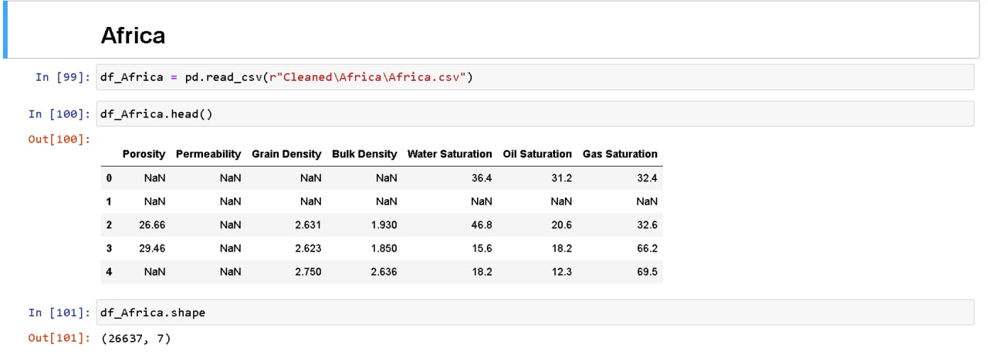

The info() method is then used to show information on the columns including labels, number of columns, number of non-null rows in each column, and data type.

**Figure 17**

Africa EDA Part 2

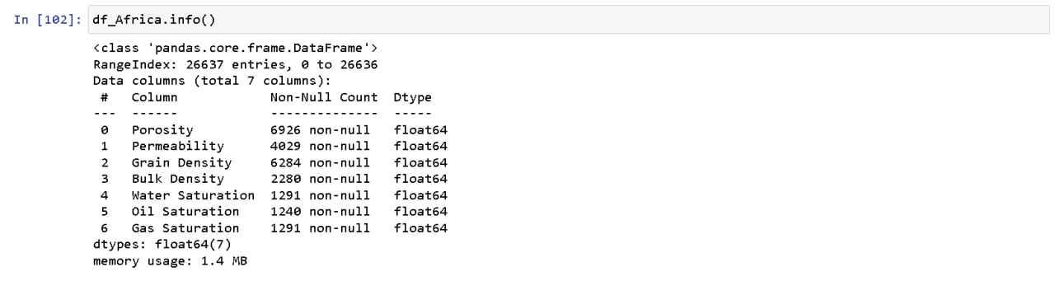

Next is the .describe(), which shows the statistical data of the columns like mean, min, and max.

**Figure 18**

Africa EDA Part 3

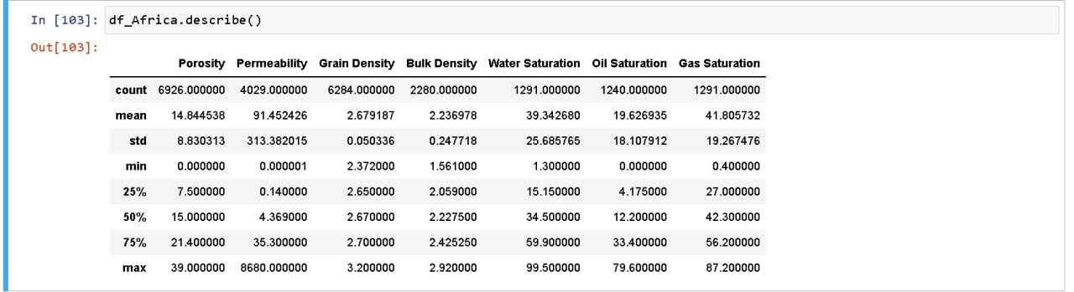

We then applied the isnull().sum() to see the number of null values in each column.

**Figure 19**

Africa EDA Part 4

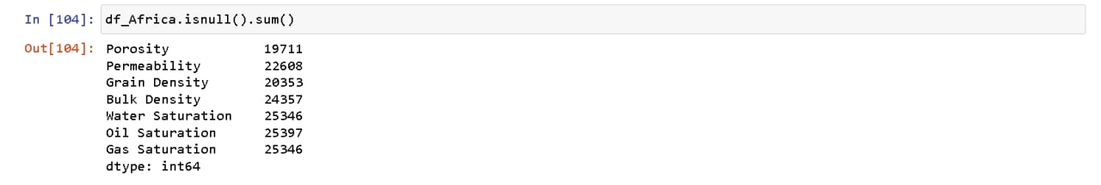

Before corr() is executed, a further step may be needed to change the column data types to the desired float type, which is part of data preparation. Finally, we use .corr() to see the correlation between columns.

**Figure 20**

Africa EDA Part 5

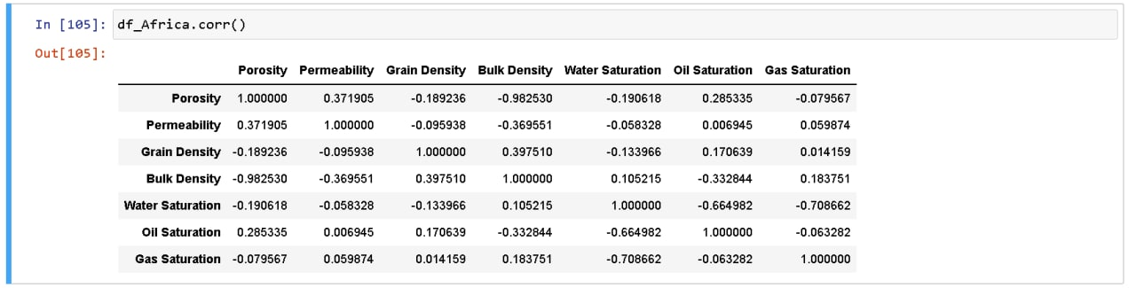

After these steps, we have a basic idea of the dataset before proceeding to clean the data. After the data is cleaned, the shape function is executed to see the final number of rows and columns.

**Figure 21**

Africa EDA Part 6



The data have been normalized using MinMaxScaler() so that all column values would be of a similar range. At this point, we plotted charts to visualize the data. The charts are a scatter plot of permeability against porosity, and two histogram plots of porosity and permeability. The goal of the plots is to observe the trend and distribution.

**Figure 22**

Africa EDA Part 7

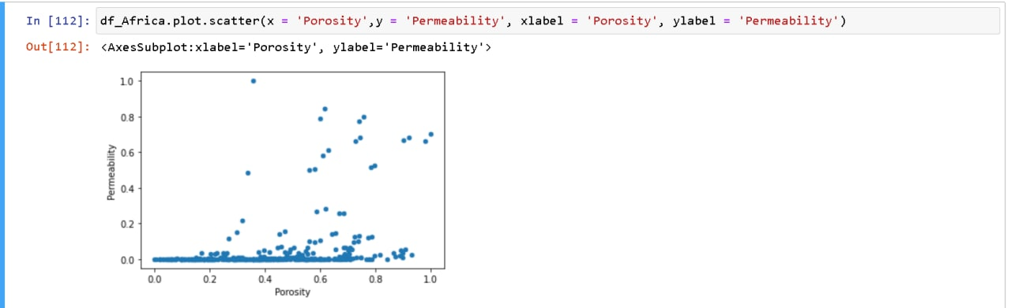

**Figure 23**

Africa EDA Part 8

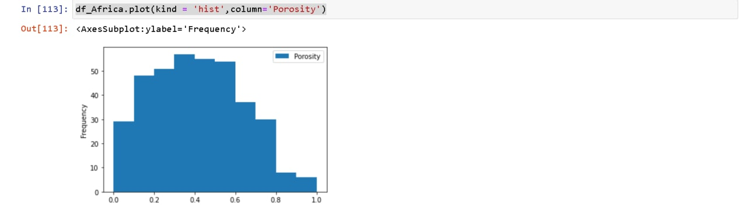 **Figure 24**

Africa EDA Part 9

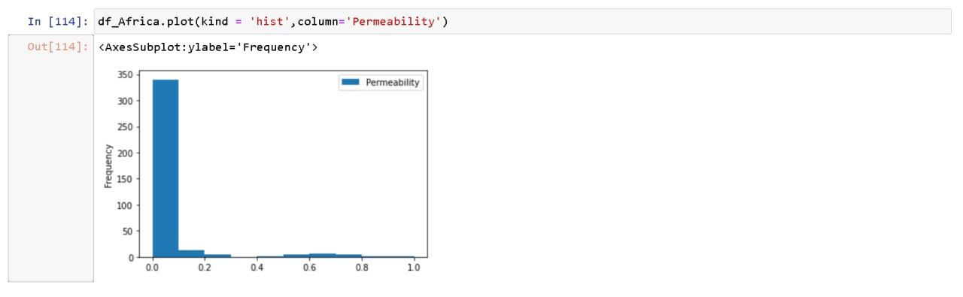

The Exploratory Data Analysis for the Africa dataset is completed at this point and is ready for training of models.

## **Chapter 3.4: Data Preparation**

Data cleaning and preparation for study mainly revolves around dealing with missing value, inappropriate data type, removal of outliers, and scaling the range of the columns to be comparable with one another.

The process for each tdataset is different from one another depending on the data available and the proportion of missing values to available data. The methods used includes dropna(), KNNImputer(), MinMaxScaler(), .replace(), to_numeric(), and deriving porosity using grain density and bulk density. dropna() is for the removal of rows with null values, parameters were changed to adjust the removal of row conditions. KNNImputer() was used to fill missing data using the KNN based on nearest neighbors. replace() was used for replacing strings into nulls. to_numeric() was used to convert the column into float type. The porosity is calculated from grain density and bulk density with the formula of $Porosity= \frac{particle density-bulk density}{particle density}$ which was taken from (Richard, 1954). The methods and processes for each dataset are different depending on the circumstances. All datasets are normalized to a range of 1 – 0. Outliers are also treated for all datasets.

Using the Africa dataset as a sample, the process of data cleaning and preparation for the dataset is as follows.

Porosity was first derived using the equation of $Porosity= \frac{particle density-bulk density}{particle density}$ from (Richard, 1954). Then, the grain and bulk density columns were dropped. Following, rows with null values were removed using dropna(), and finally, outliers were treated by removing data that are 3 standard deviations away from each column’s standard deviation and mean. A isnull().sum() is executed after to ensure that all missing values have been dealt with.

**Figure 25**

Africa Data Cleaning

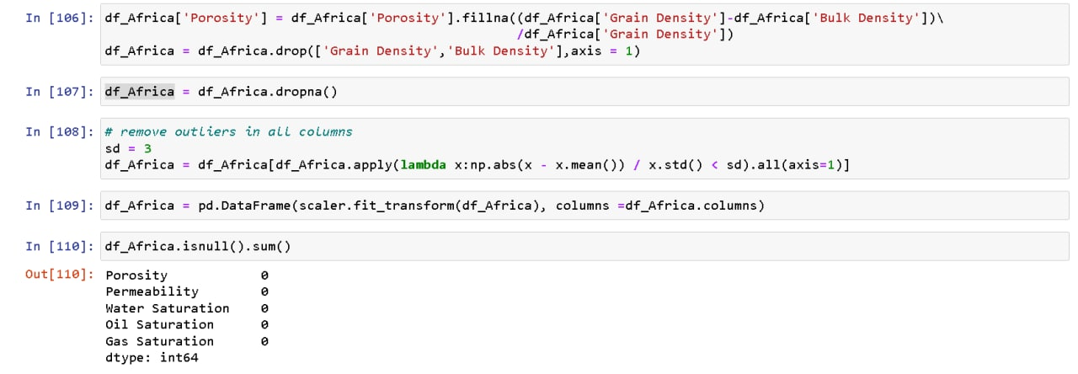

After the data is cleaned, the Exploratory Data Analysis is continued as previously mentioned.

The Exploratory Data Analysis, data cleaning, and preparation process as well as the screenshots of the output are attached in the appendix.

# **Chapter 4: Proposed Modelling and Evaluation**

## **Chapter 4.1: Proposed Modelling**

In this project, the unsupervised learning algorithms that will be used are the K-means, Centroid Neural Network (CentNN), DBSCAN, BIRCH, and Gaussian Mixture Models (GMM) algorithms. Different types of clustering algorithms are considered for the same sets of data. The models proposed are considered top algorithms for unsupervised learning algorithms and we will compare each model’s performance against one another for any given dataset for the eleven core datasets.

## **Chapter 4.2: Evaluation**

For evaluation of performance between the unsupervised learning algorithms on all eleven datasets, the following metrics will be used. The Adjusted Rand Index, the Jaccard Index, the Silhouette score, and the Dunn Index. Based on the metrics, models are evaluated as a whole relative to other algorithms and on each dataset.

# **Chapter 5: Proposed Schedule**

**Table 1**

Proposed Schedule

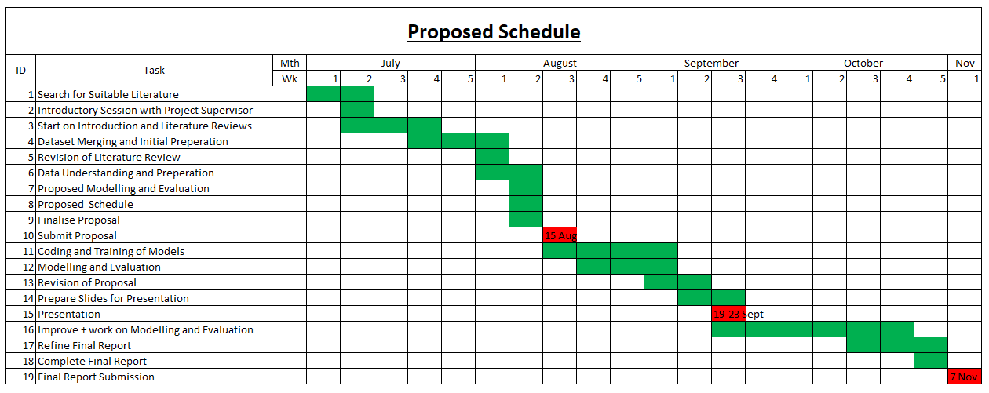

# **References**

Data Underground (n.d.). [Data sets]. https://dataunderground.org/

Dutta, S. (2022, April 19). *Oil and gas production - an introduction*. Oil & Gas IQ. Retrieved from https://www.oilandgasiq.com/oil-and-gas-production-and-operations/articles/oil-and-gas-production

Geomore. (n.d.). *Porosity and Permeability*. Oil on my shoes – the original petroleum geology site! Retrieved August 14, 2022, from https://www.geomore.com/porosity-and-permeability-2/#:~:text=Porosity%20consists%20of%20the%20tiny,to%20flow%20through%20the%20rock

GeoPovider (n.d.) North_Sea [Data sets]. https://www.geoprovider.no/

Hollis, C., Vahrenkamp, V., Tull, C., MookerJee, A., Taberner, C., & Huang, Y. (2010). Pore system characterization in heterogeneous carbonates: An alternative approach to widely-used rock-typing methodologies. *Marine and Petroleum Geology, 27*(4) 772-793. https://doi.org/10.1016/j.marpetgeo.2009.12.002

IBM Cloud Education. (2020, July 15). *What is machine learning?* IBM. Retrieved from https://www.ibm.com/cloud/learn/machine-learning

Rodriguez, M. Z., Comin, C. H., Casanova, D., Bruno, O. M., Amancio, D. R., Costa, L. da F., Rodrigues, F. A., & Kestler, H. A. (2019). Clustering algorithms: A comparative approach. *PloS One, 14*(1), e0210236–e0210236. https://doi.org/10.1371/journal.pone.0210236

Faramarzi-Palanga, M., & Mirzaer-Paiaman, A. (2021). Investigating dynamic rock quality in two-phase flow systems using TEM-function: A comparative study of different rock typing indices. *Petroleum Research, 6*(1), 16-25. http://doi.org.suss.remotexs.co/10.1016/j.ptlrs.2020.08.001

Mirzaei-Paiaman, A., Asadolahpour, S. R., Saboorian-Jooybari, H., Chen, Z., & Ostadhassan, M. (2020). A new framework for selection of representative samples for special core analysis. *Petroleum Research, 5*(3), 210–226. https://doi.org/10.1016/j.ptlrs.2020.06.003

Mohamed, I. M., Mohamed, S., Mazher, I., & Chester, P. (2019). *Formation Lithology Classification: Insights into Machine Learning Methods* [Paper Presentation].Paper presented at the SPE Annual Technical Conference and Exhibition, Calgary, Alberta, Canada, September 2019*.* https://doi.org/10.2118/196096-MS

Mohammadian, E., Kheirollahi, M., Liu, B., Ostadhassan, M., & Sabet, M. (2022). A case study of petrophysical rock typing and permeability prediction using machine learning in a heterogenous carbonate reservoir in Iran. *Scientific Reports*, *12*(1), 4505–4505. https://doi.org/10.1038/s41598-022-08575-5

National Geographic. (n.d.). *Petroleum*. National Geographic Society. Retrieved from https://education.nationalgeographic.org/resource/petroleum

Richards, L. A. (1954). Diagnosis and Improvement of. *Saline and Alkali Soils. Handbook*, *60*.

ScienceDirect. (n.d.). *Sedimentary Basin*. Sedimentary Basin - an overview | ScienceDirect Topics. Retrieved from https://www.sciencedirect.com/topics/earth-and-planetary-sciences/sedimentary-basin

Shahat, J. S., Mohamed, I. B., Mahamed, S. E., & Attia, M. A. (2021). Resistivity zone index: A new approach in rock typing to enhance reservoir characterization using well log data. *Energy Reports, 7*, 711-723. http://doi.org.suss.remotexs.co/10.1016/j.egyr.2021.01.026

Soleymanzadeh, A., Parvin, S., & Kord, S. (2019). Effect of overburden pressure on determination of reservoir rock types using RQI/FZI, FZI* and Winland methods in carbonate rocks. *Petroleum Science, 16*(6), 1403-1416 https://doi.org/10.1007/s12182-019-0332-8

Tavakoli, V. (2018). Rock Typing. *Geological Core Analysis*, 85-99. https://doi.org/10.1007/978-3-319-78027-6_6

UK National Data Repository (n.d.). UK [Data sets]. https://ndr.nstauthority.co.uk/

Zakyan, Permadi, A. K., Pratama, E. A., & Naufaliansyah, M. A. (2022). An Improved Method of Clay-Induced Rock Typing Derived from Log Data in Modelling Low Salinity Water Injection: A Case Study on an Oil Field in Indonesia. *Energies (Basel)*, *15*(10), 3749–. https://doi.org/10.3390/en15103749

# **Appendix A**

**Dataset Initial Preparation and Merging (Codes & Output)**

## **A.1: Africa**

**Figure 26**

Africa Dataset

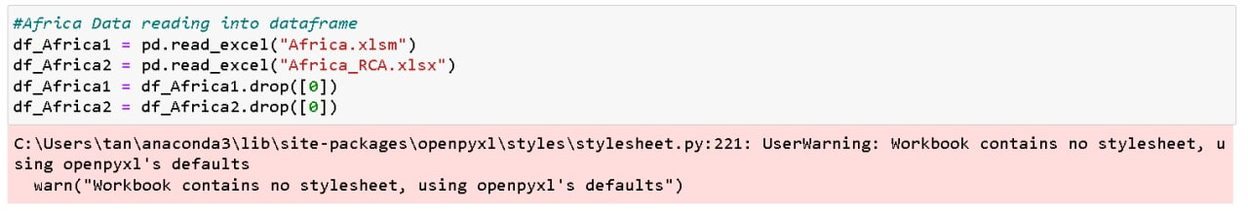 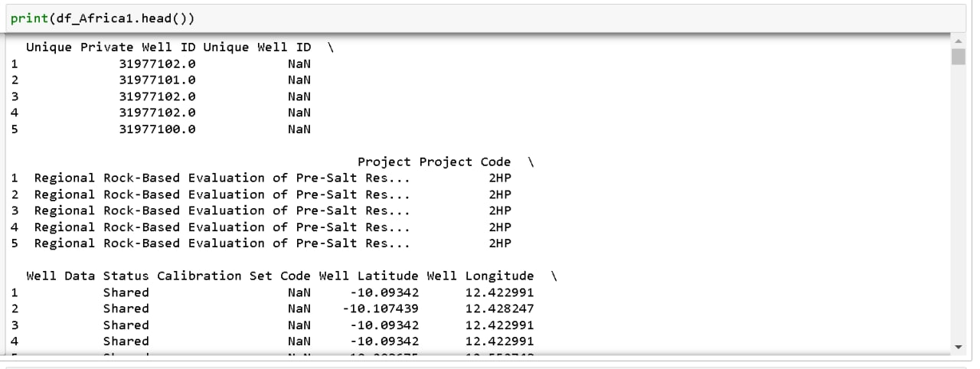 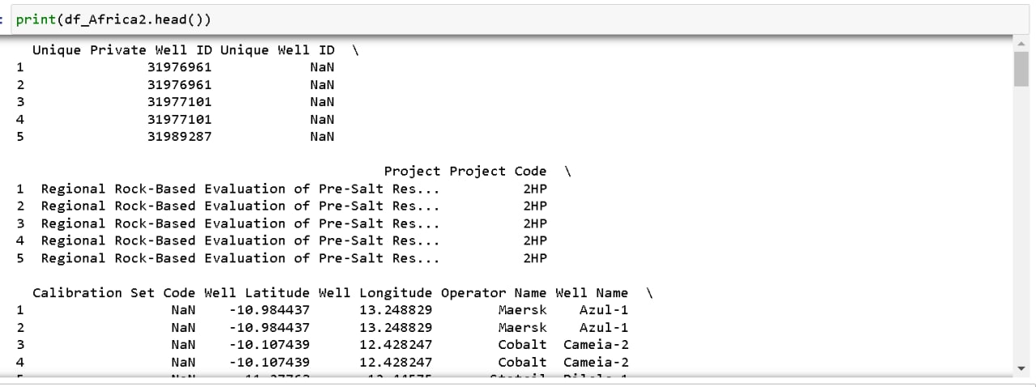 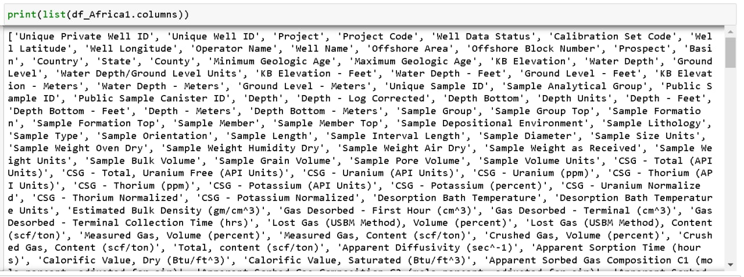 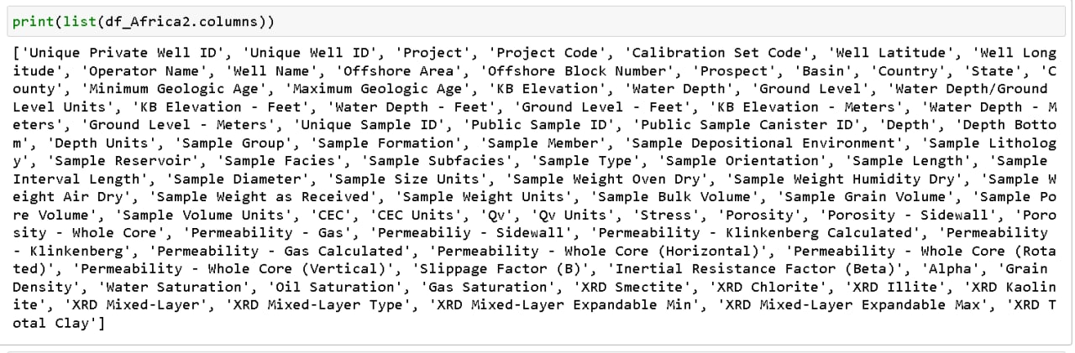 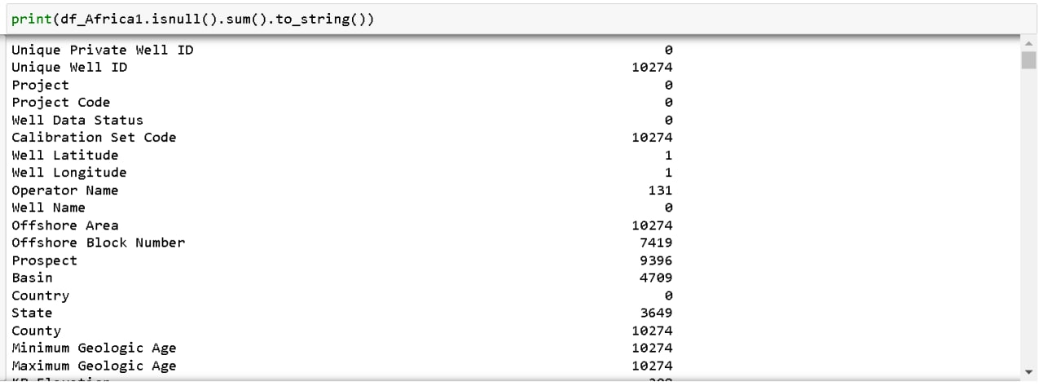 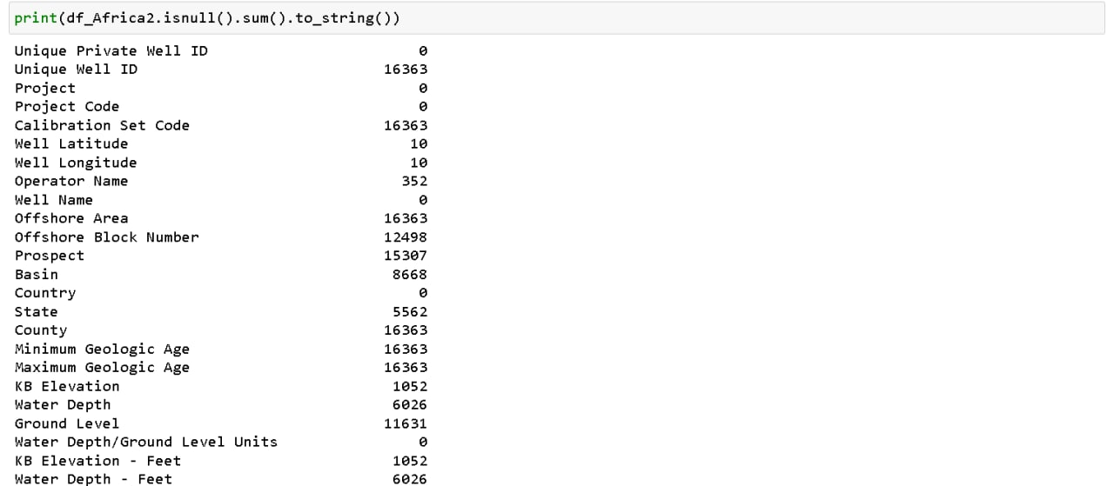 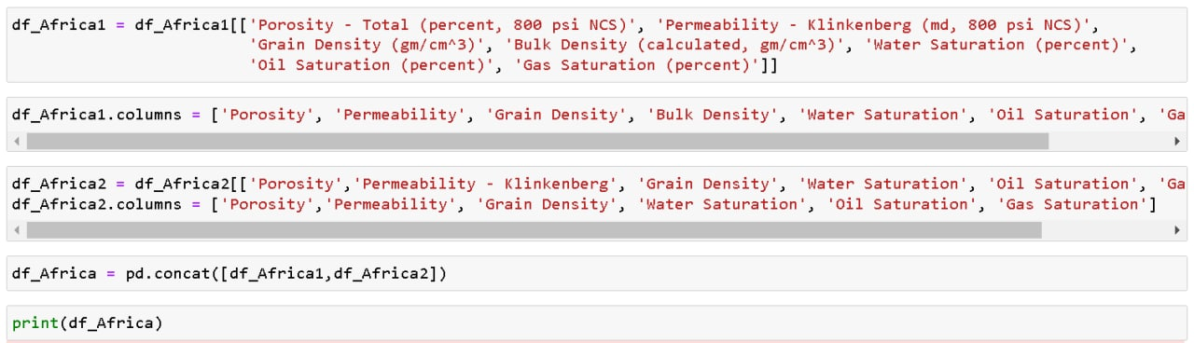 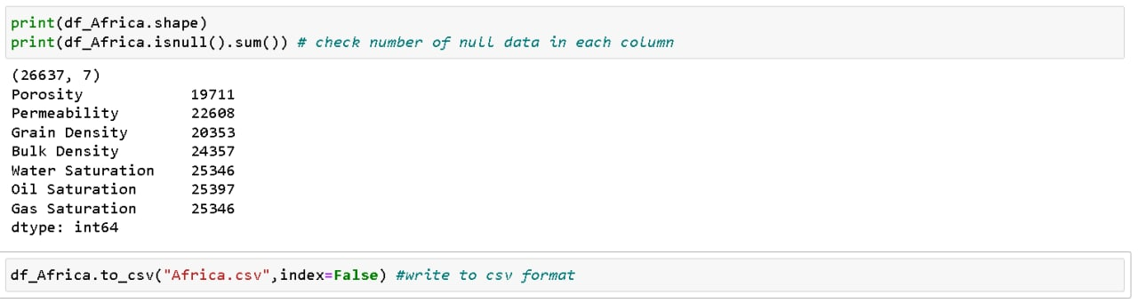

## **A.2: Australia**

**Figure 27**

Australia Dataset

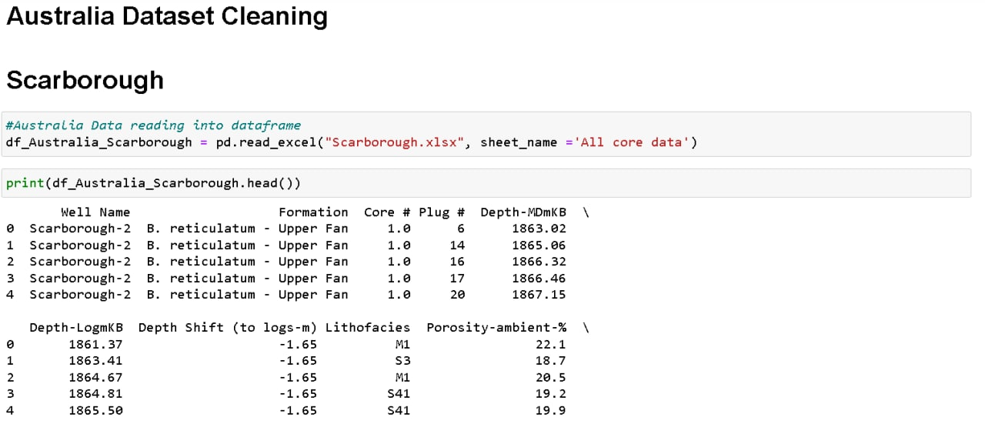

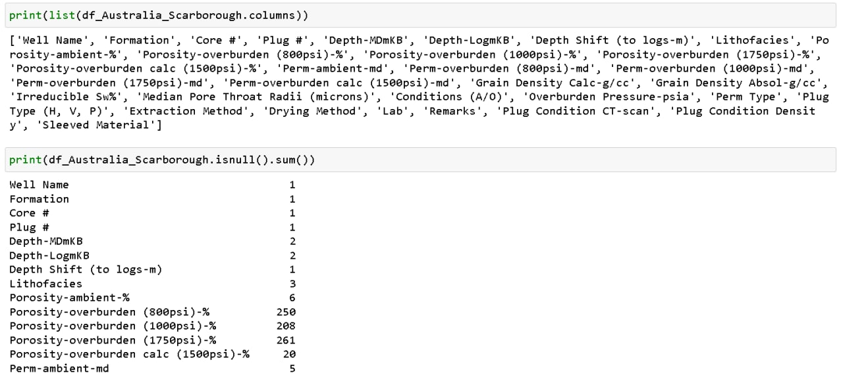 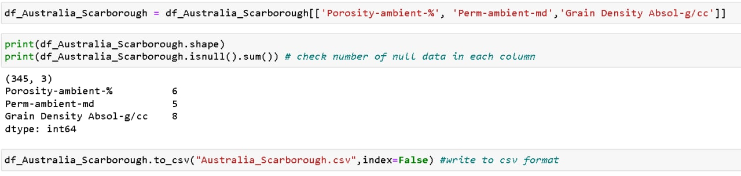 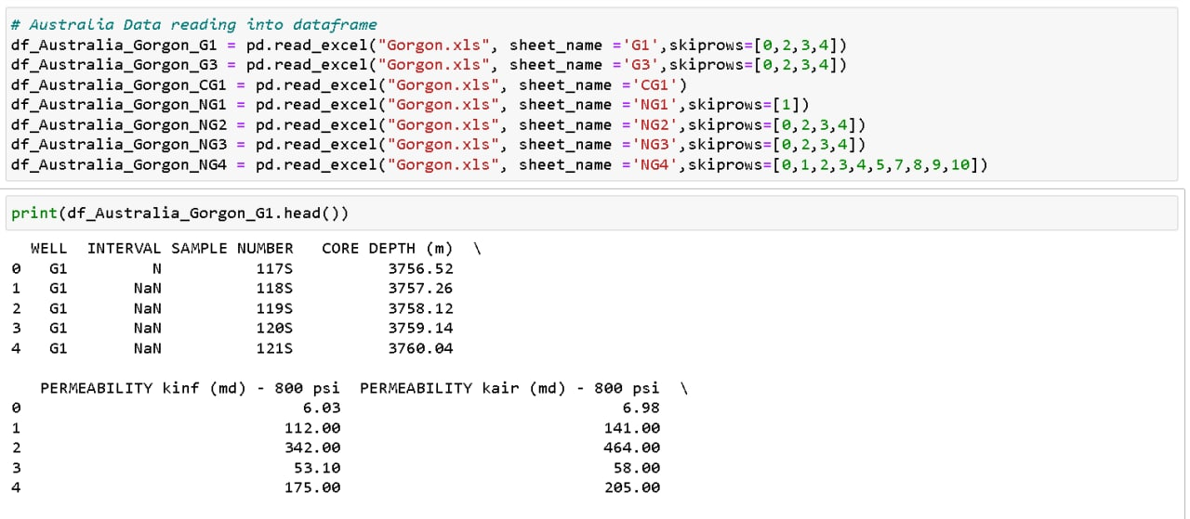 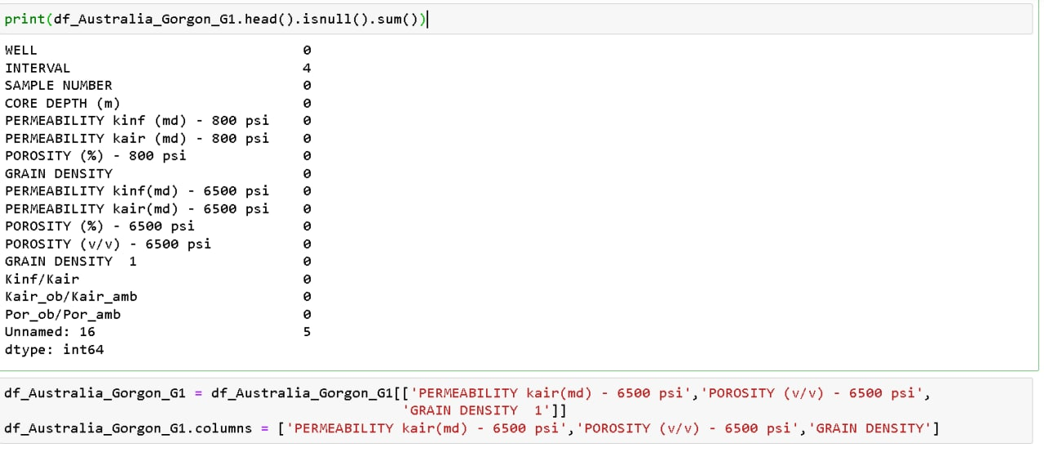 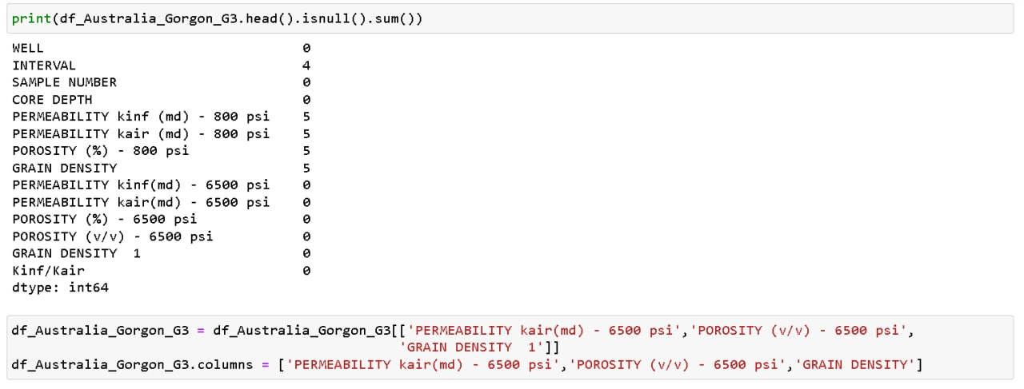 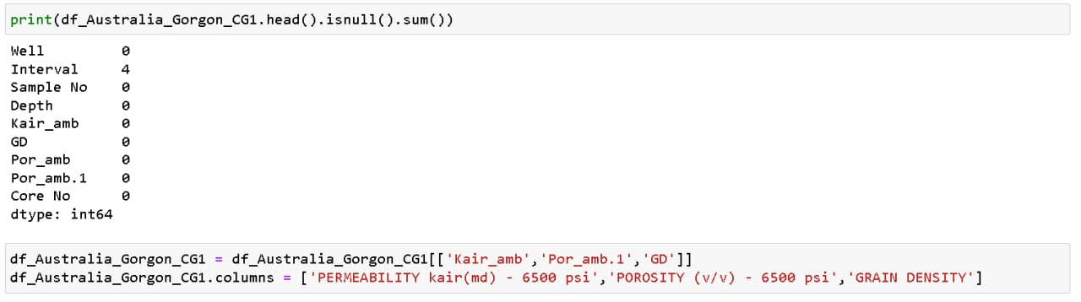 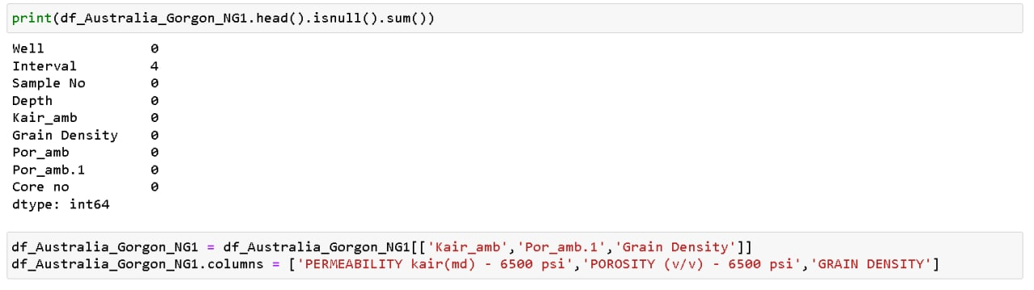 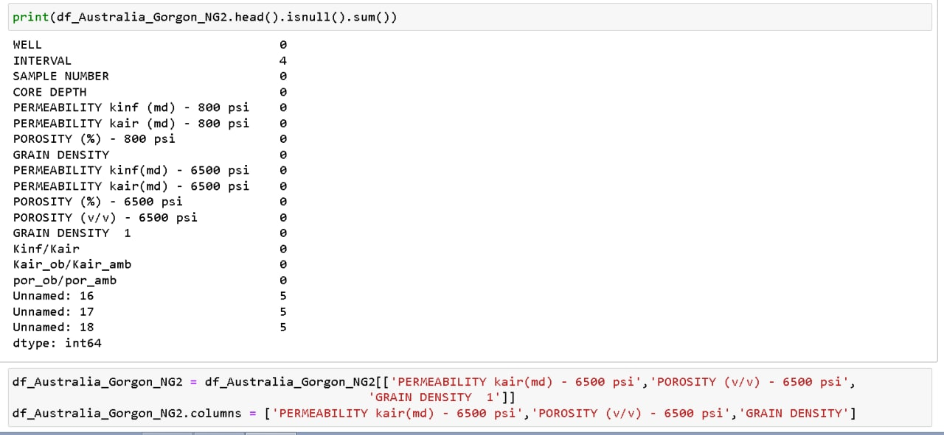 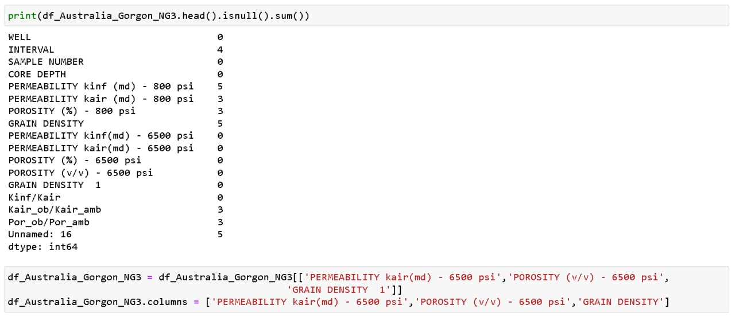 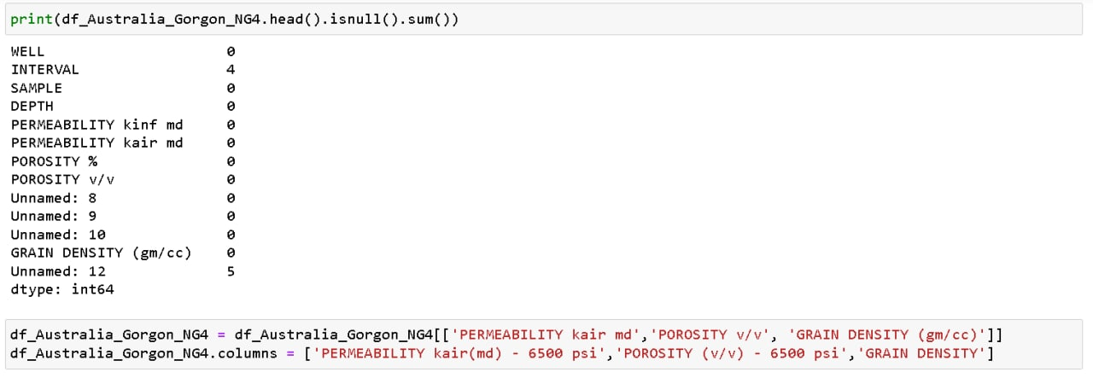 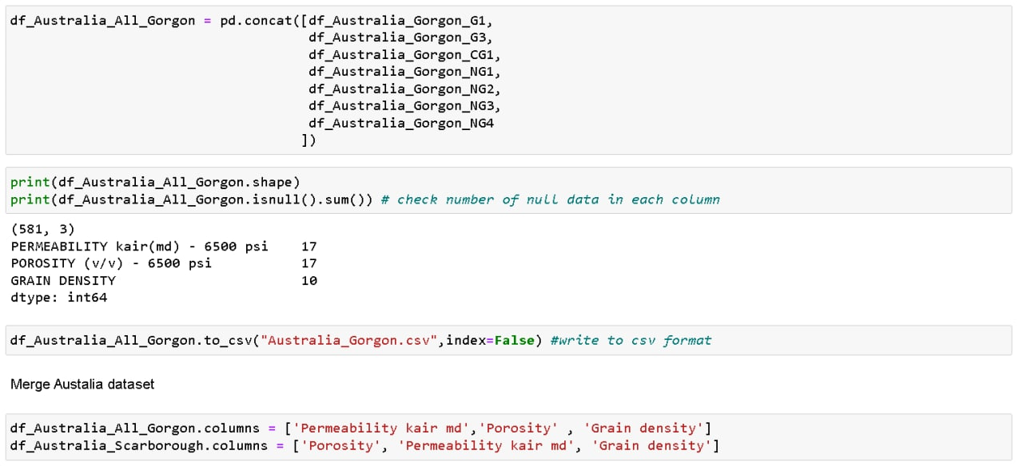 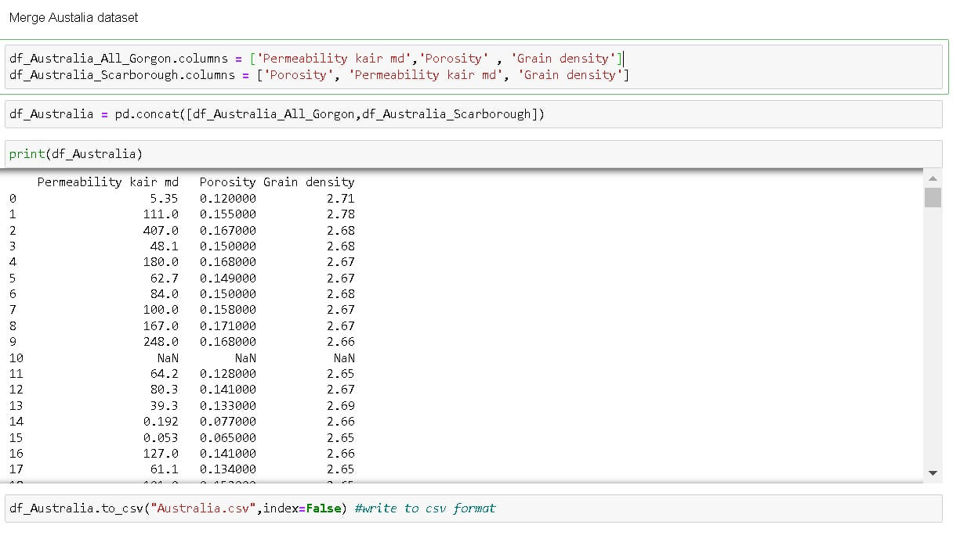

## **A.3: Brazil**

**Figure 28**

Brazil Dataset

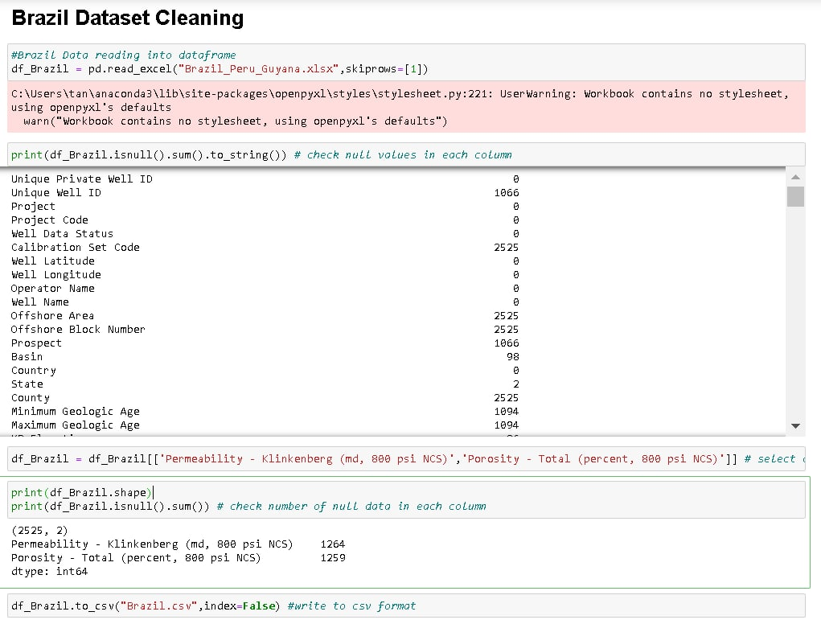

## **A.4: China**

**Figure 29**

China Dataset

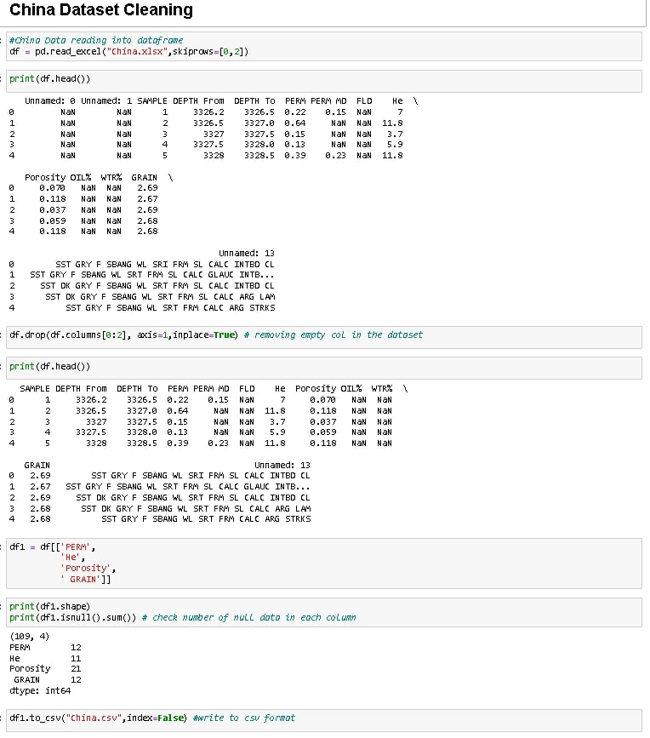

## **A.5: Myanmar**

**Figure 30**

Myanmar Dataset

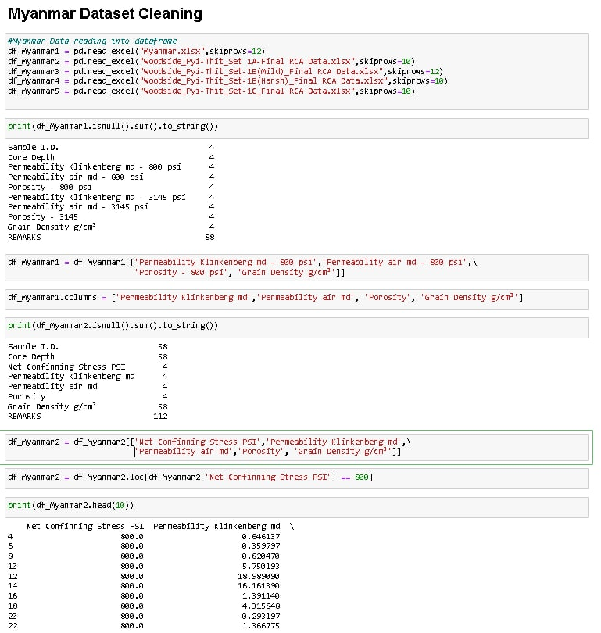

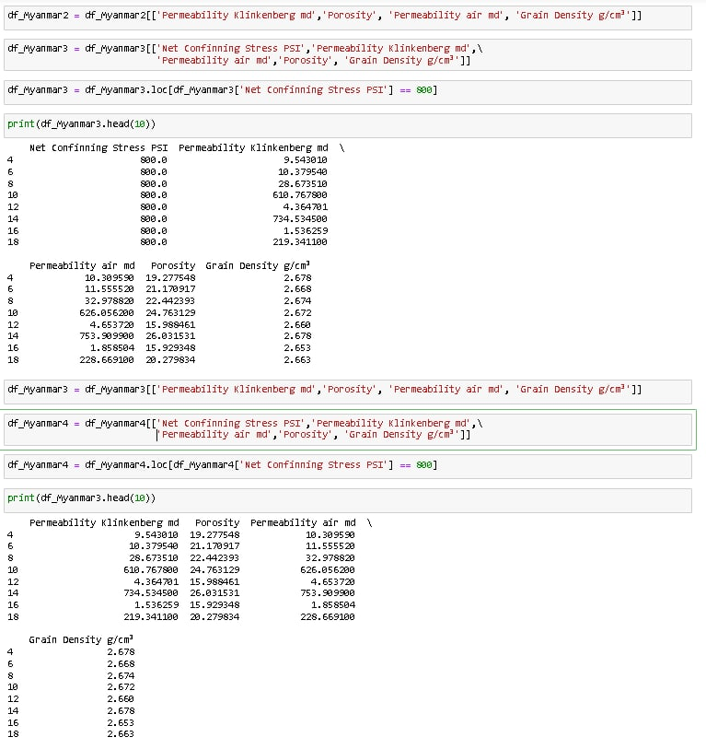 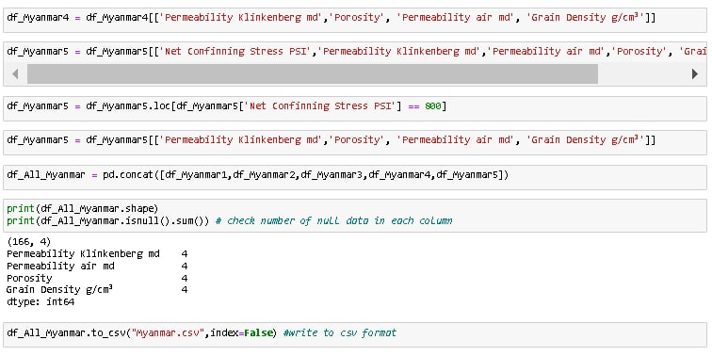

## **A.6: North Sea**

**Figure 31**

North Sea Dataset

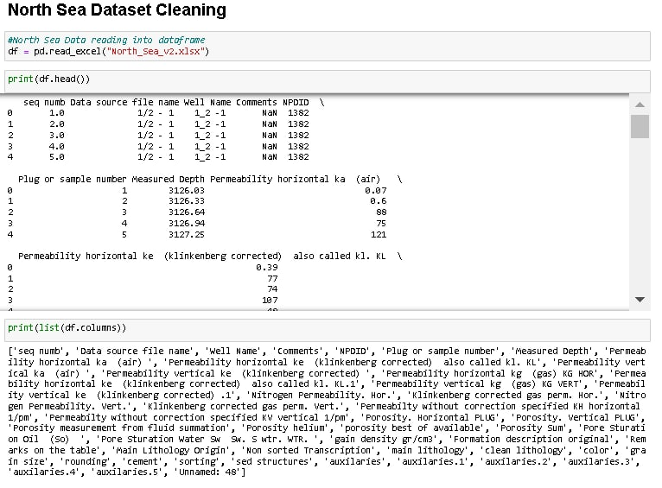

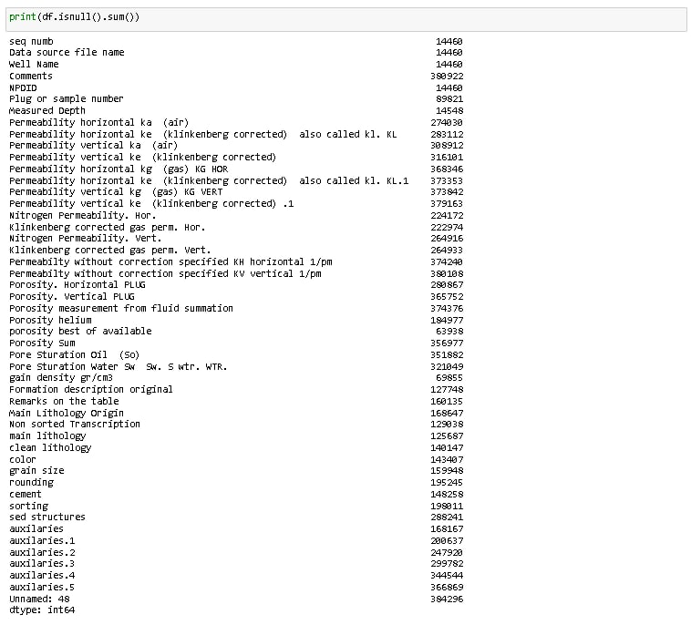

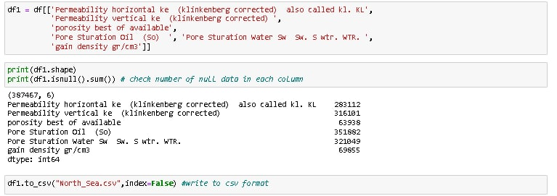

## **A.7: Philippines**

**Figure 32**

Philippines Dataset

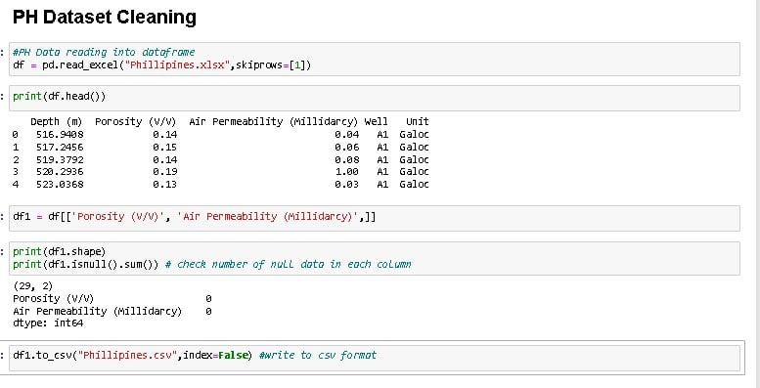

## **A.8: Pakistan**

**Figure 33**

Pakistan Dataset

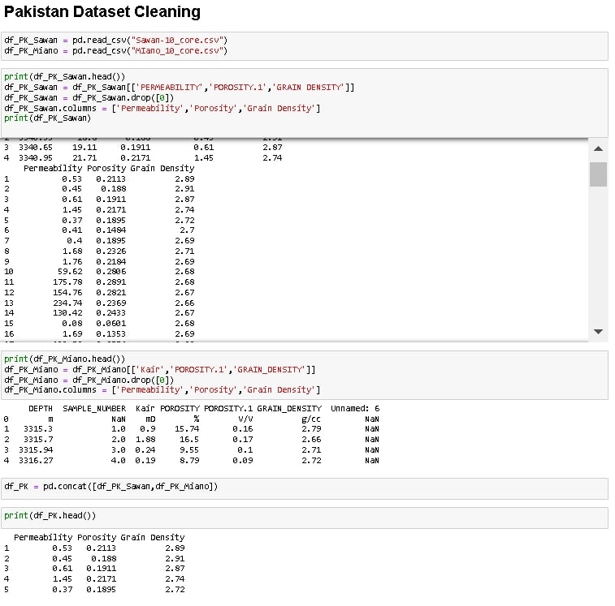 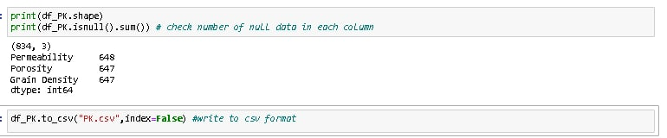

## **A.9: Papua New Guinea**

**Figure 33**

Papua New Guinea Dataset

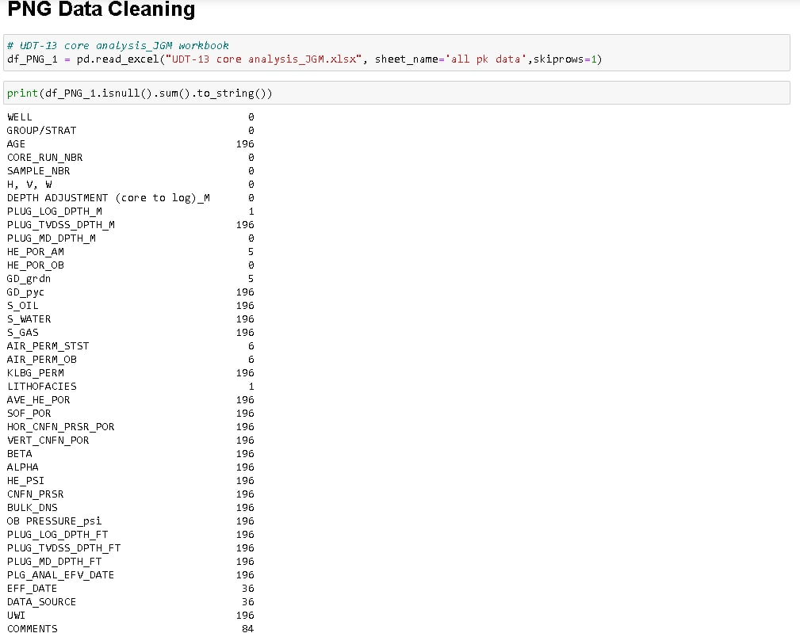

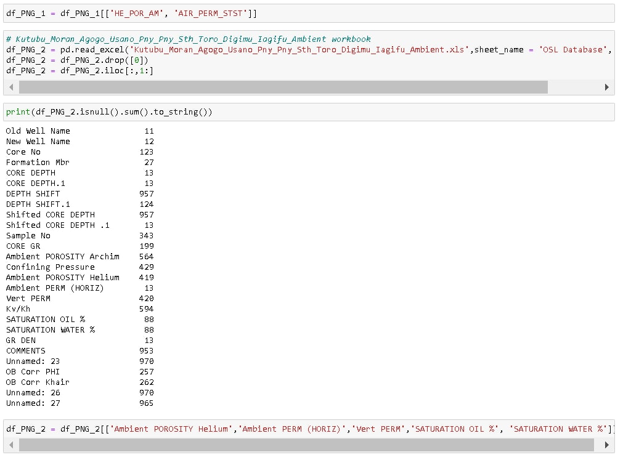

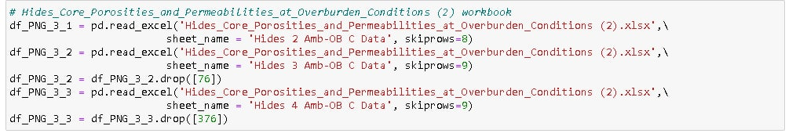 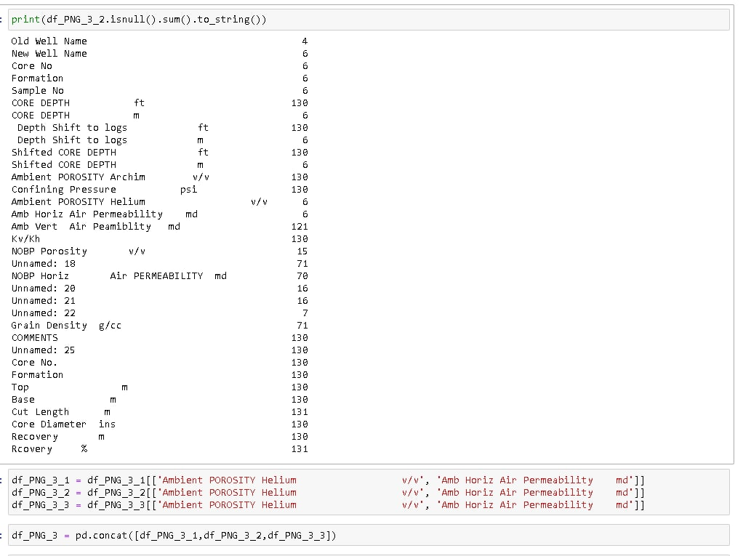 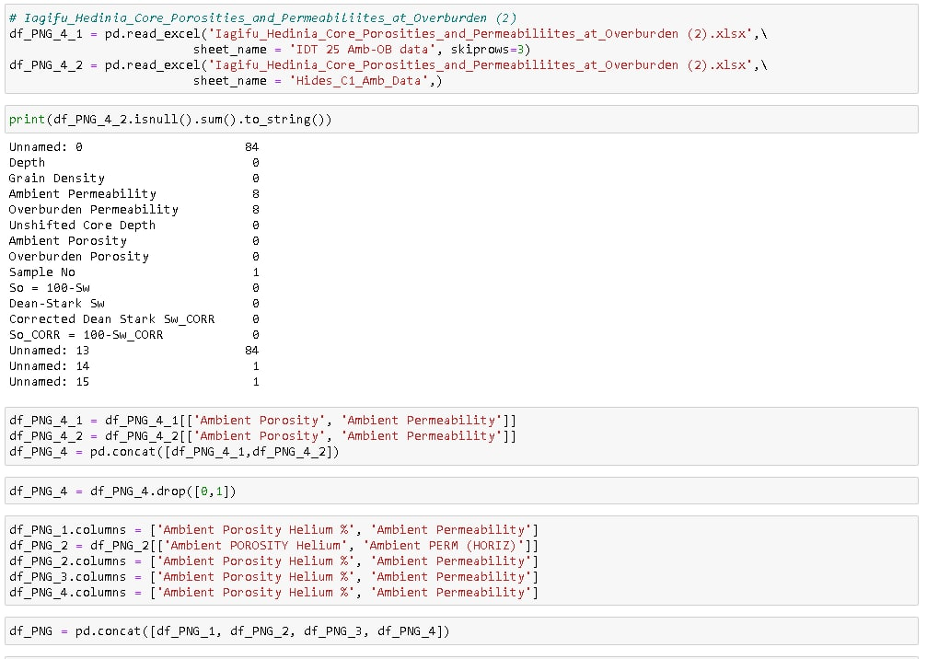

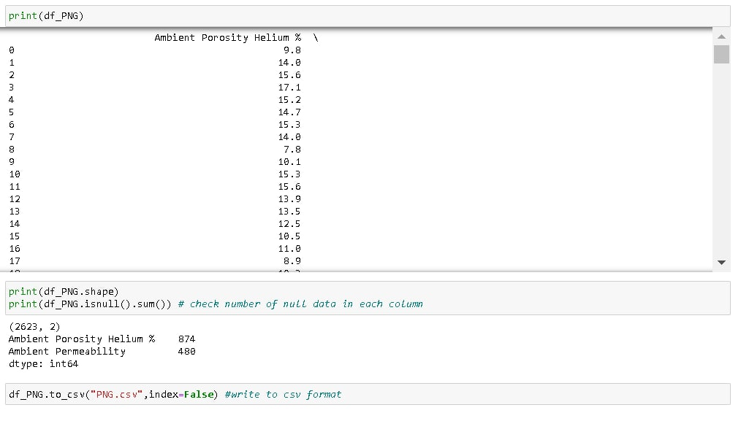

## **A.10: United Kingdom**

**Figure 34**

United Kingdom Dataset

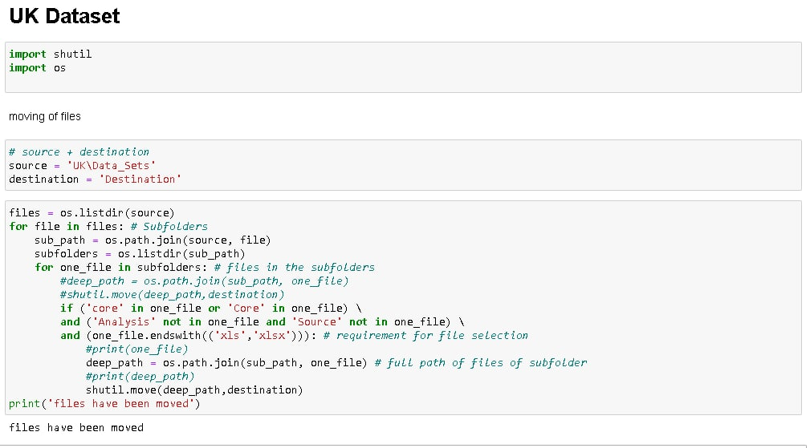

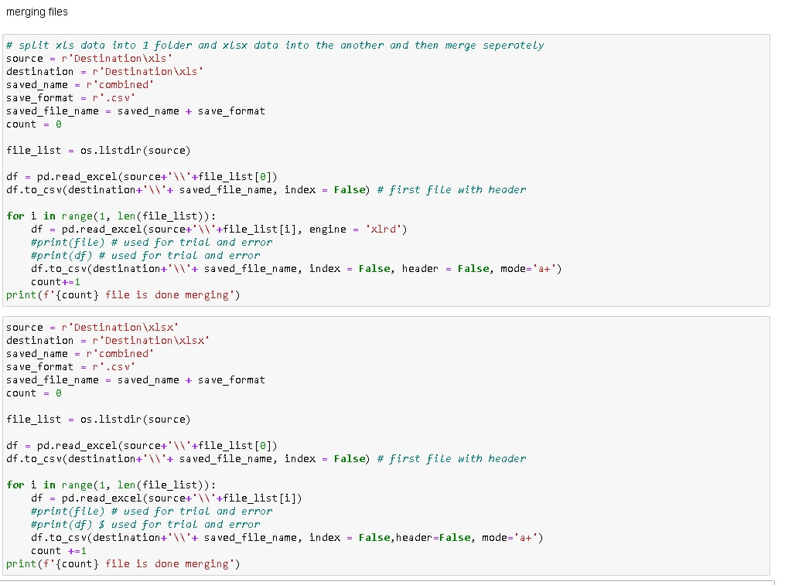 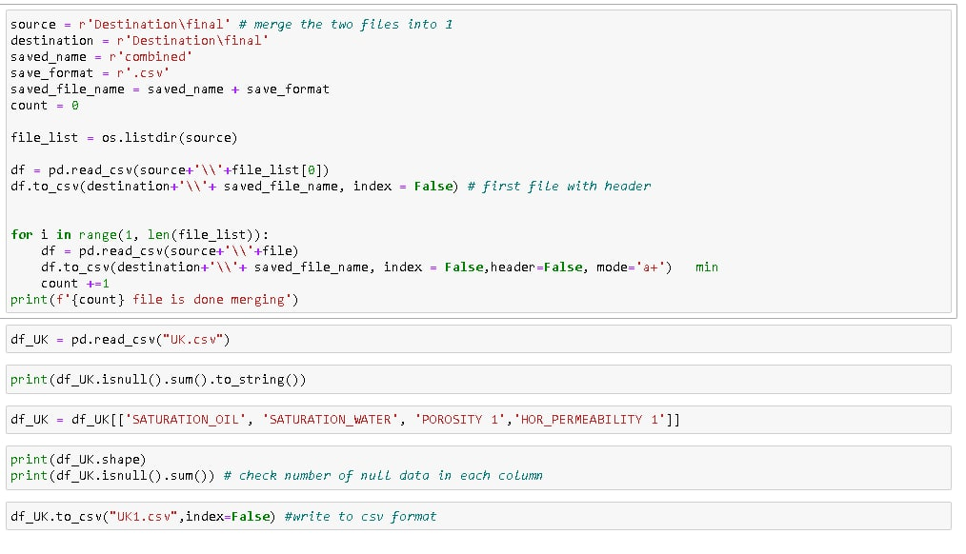

## **A.11: United States of America**

**Figure 35**

United States of America Dataset

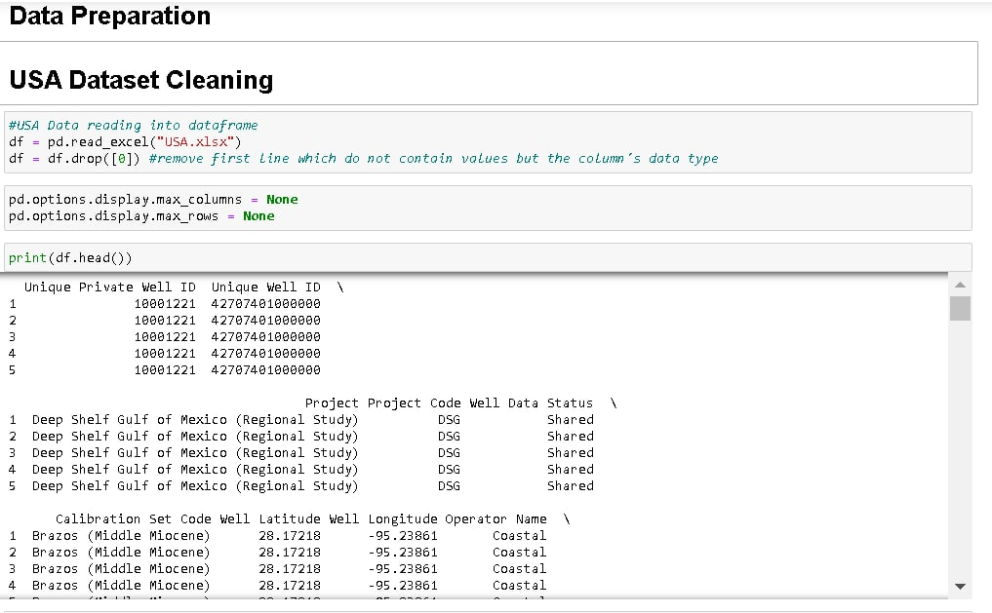

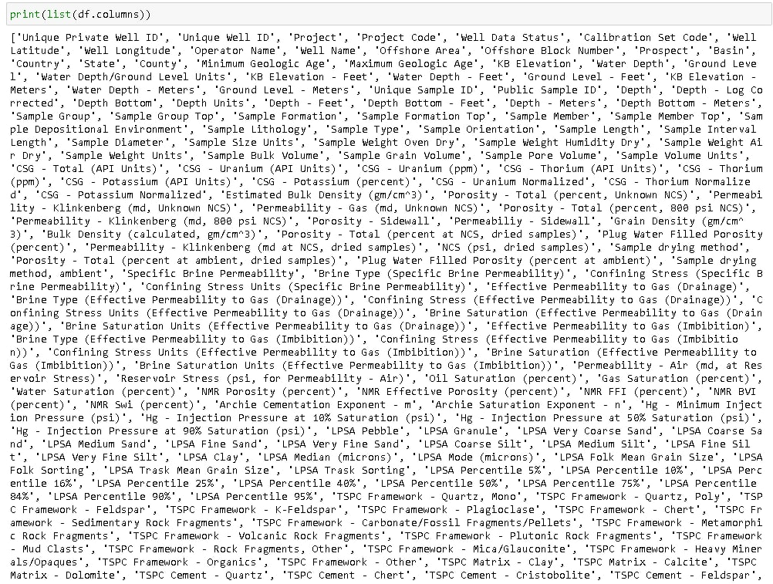 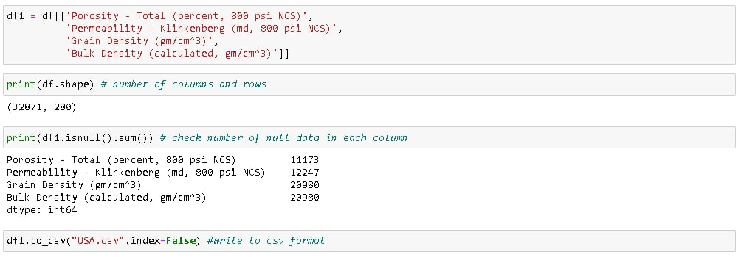

# **Appendix B**

**Dataset Preparation and Understanding (Codes & Output)**

## **B.1: Africa**

**Figure 36**

Africa Dataset

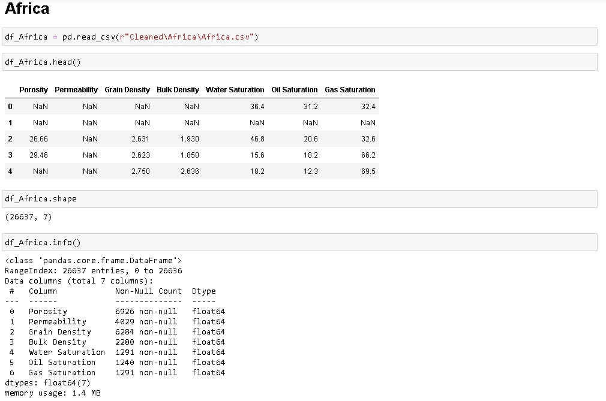

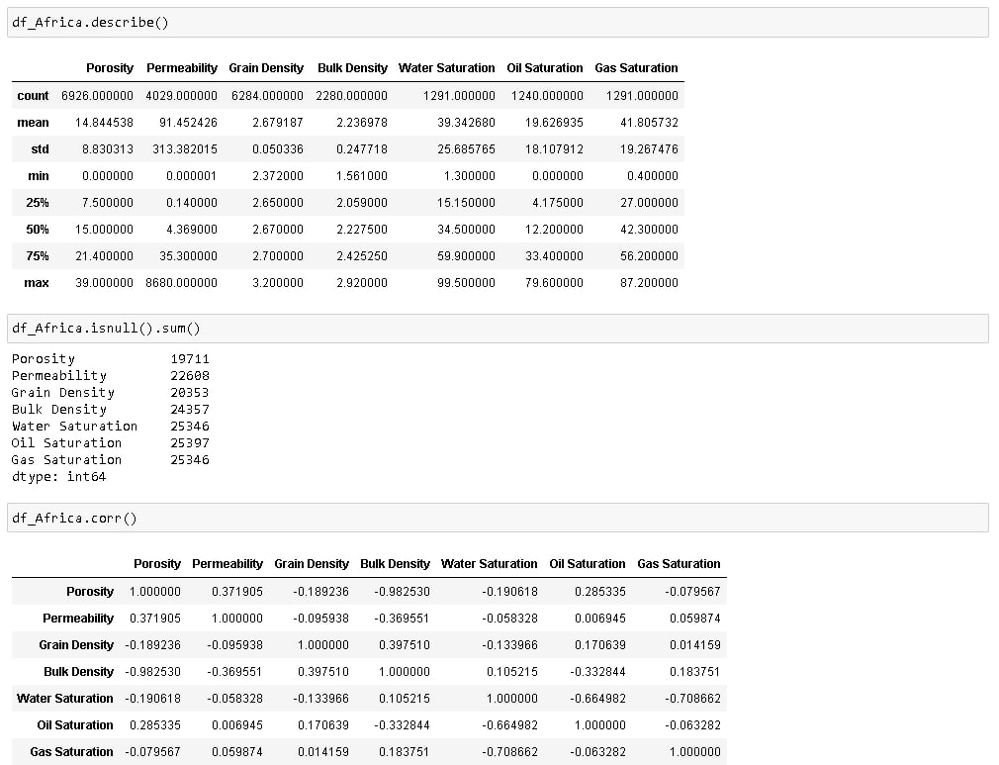 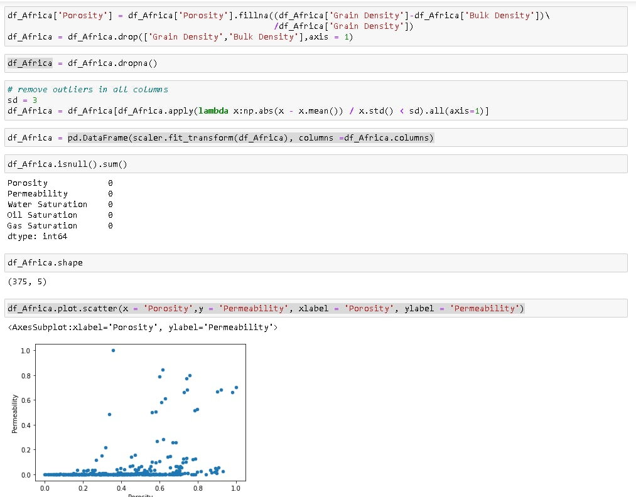 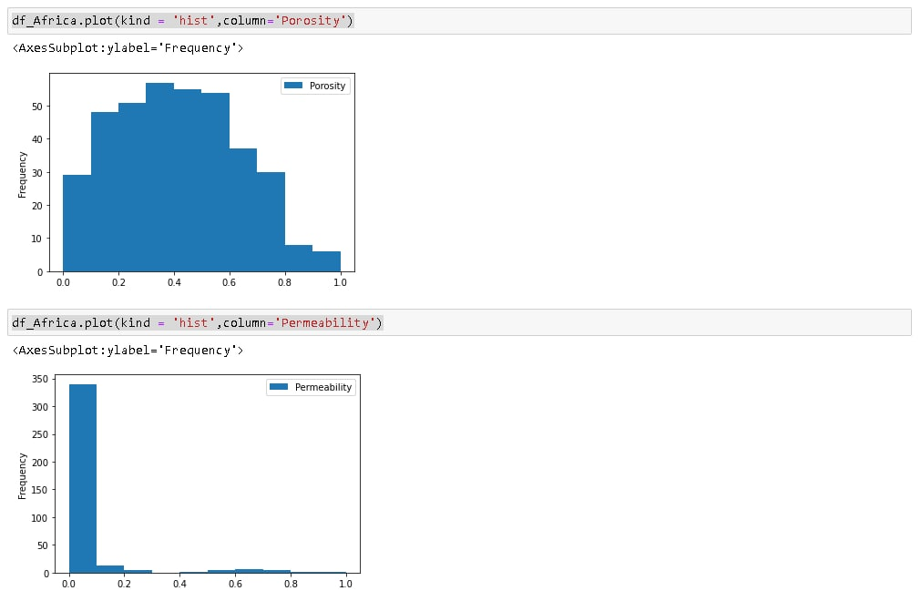

## **B.2: Australia**

**Figure 37**

Australia Dataset

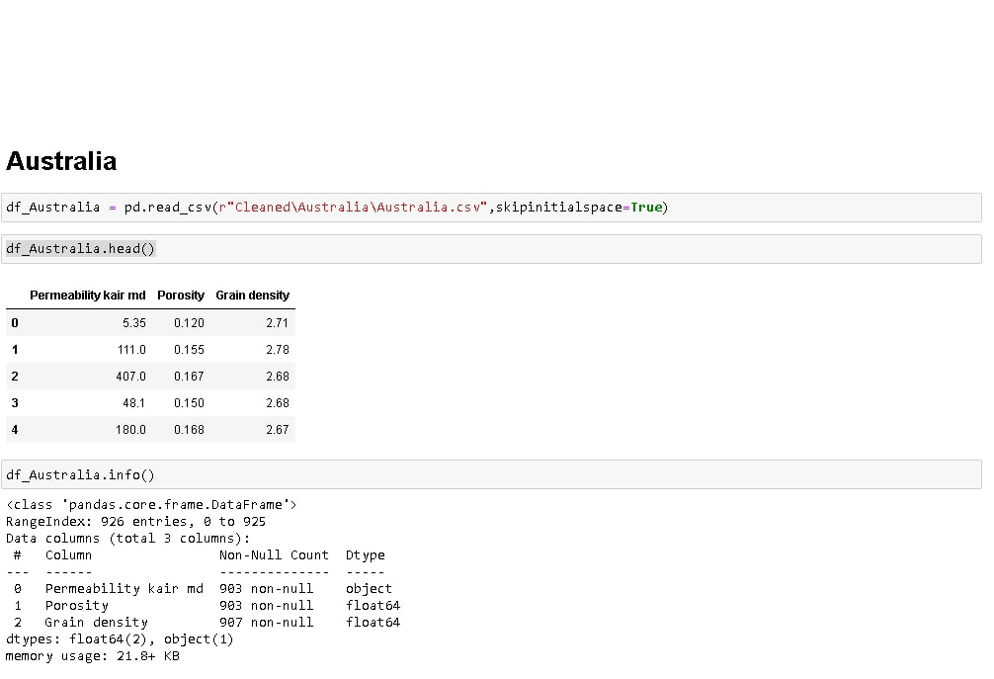

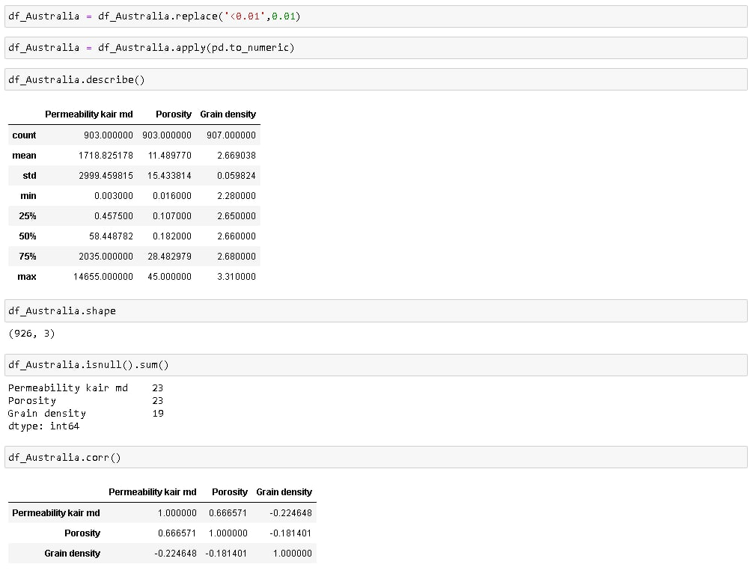 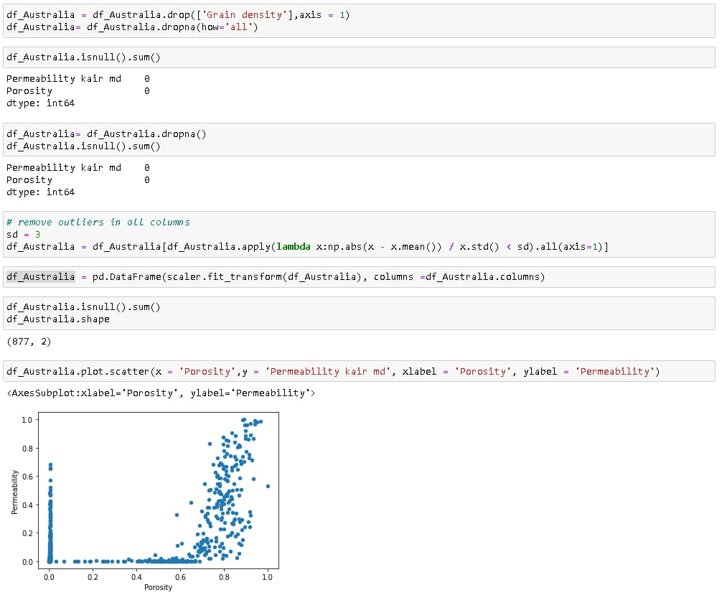 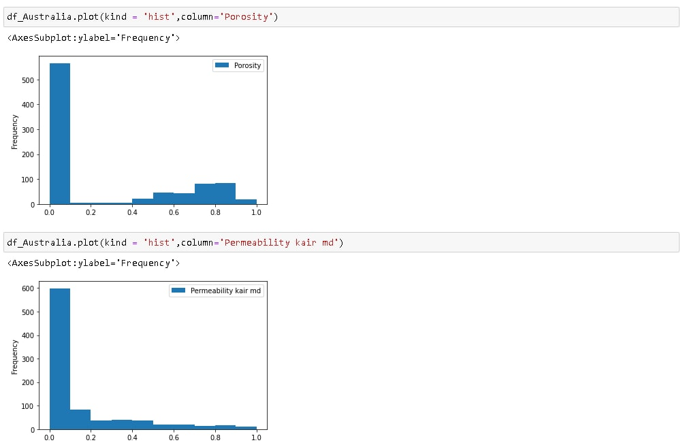

## **B.3: Brazil**

**Figure 38**

Brazil Dataset

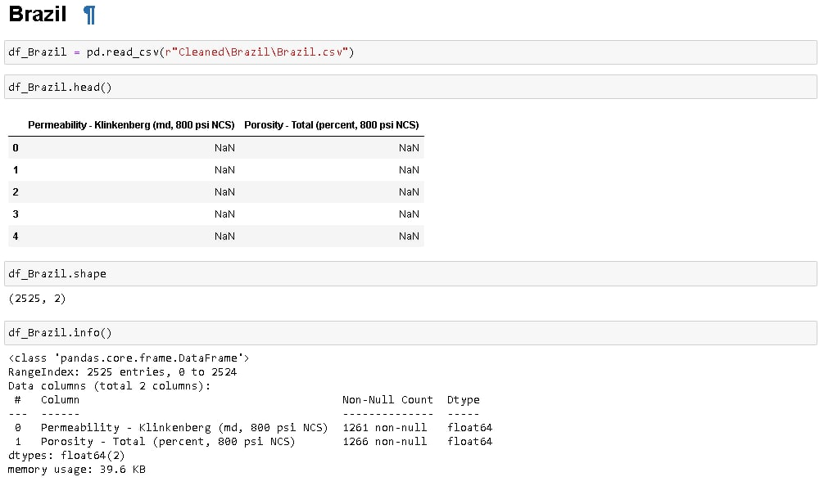

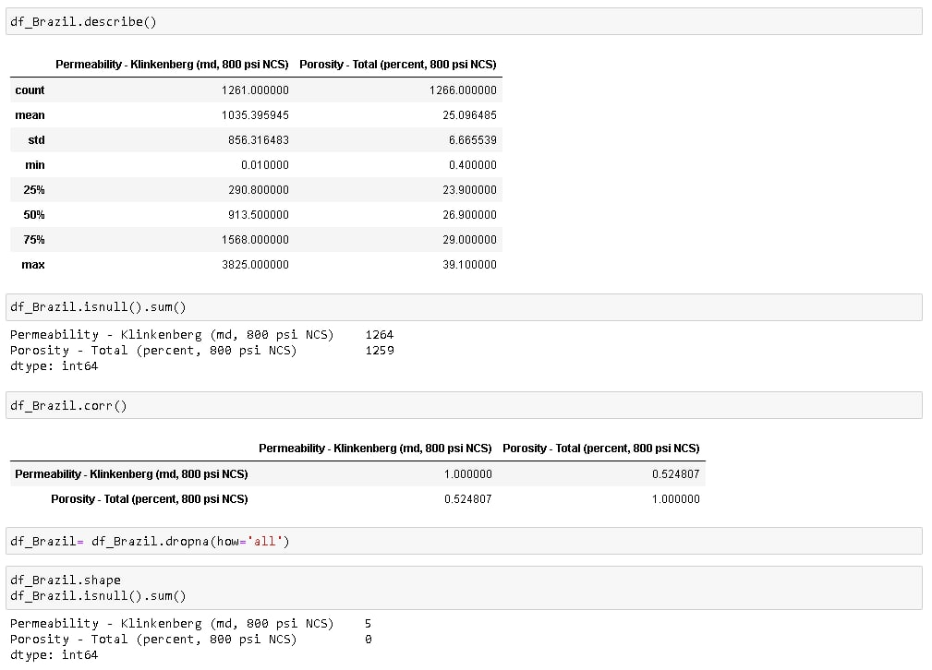 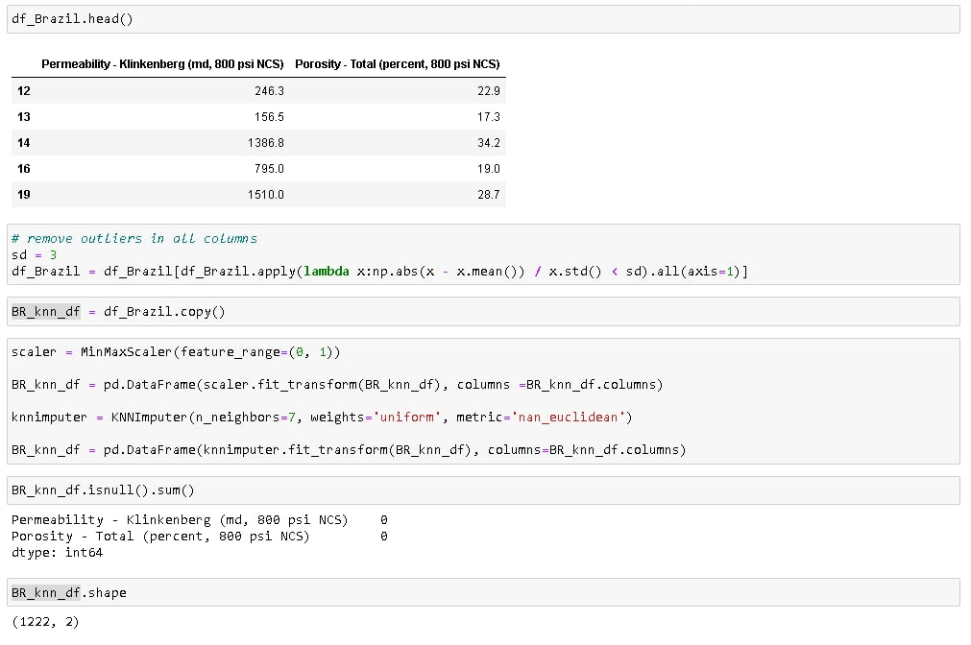 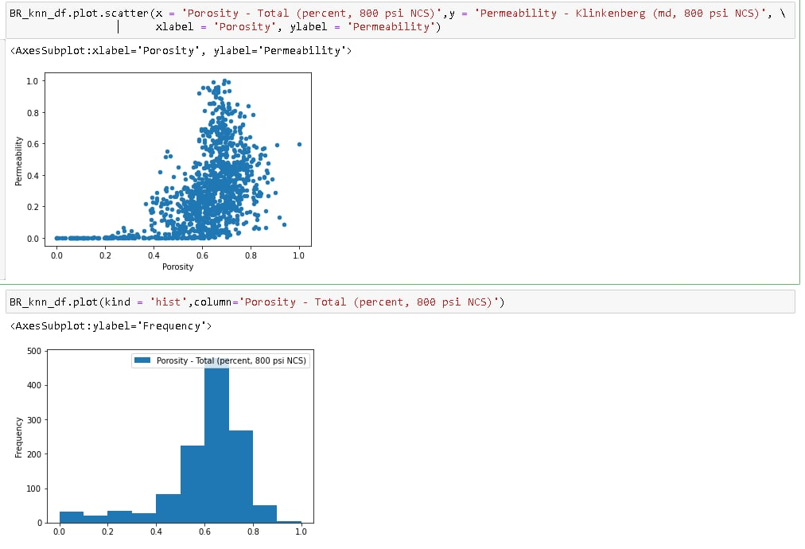 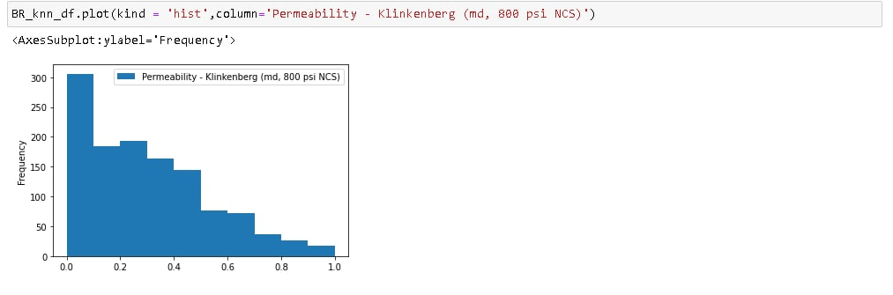

## **B.4: China**

**Figure 39**

China Dataset

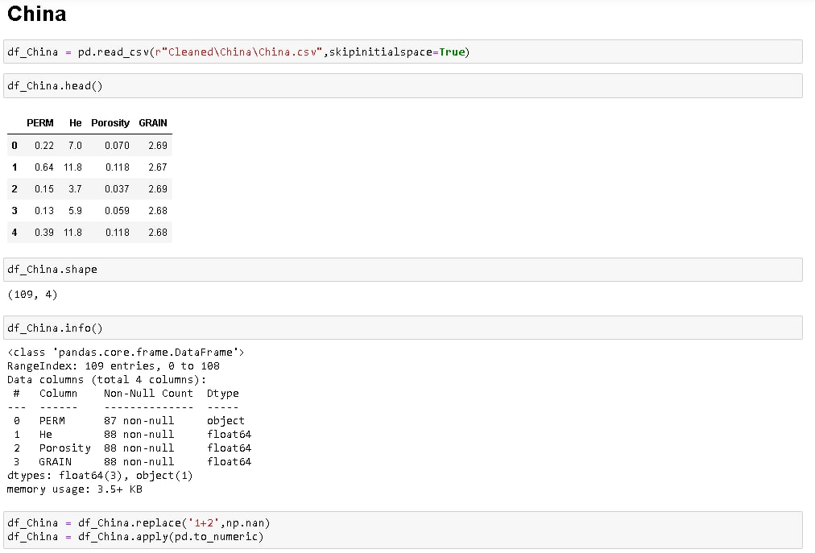

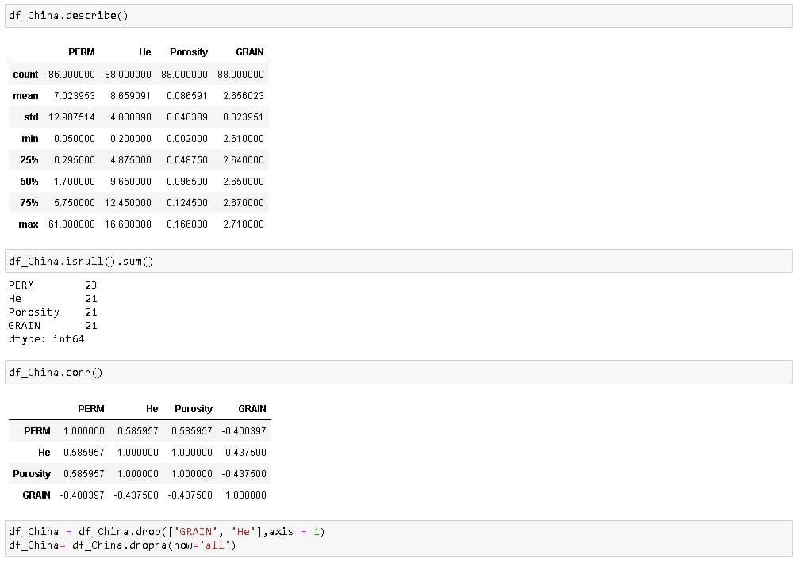

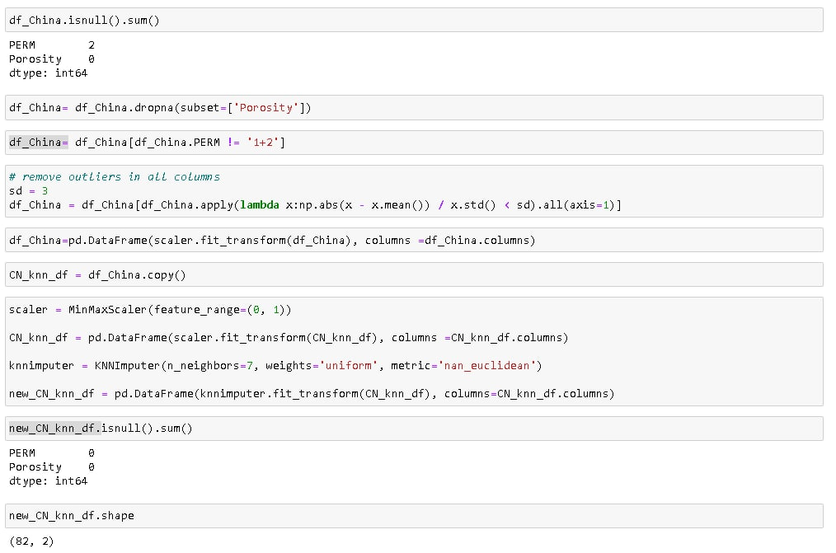 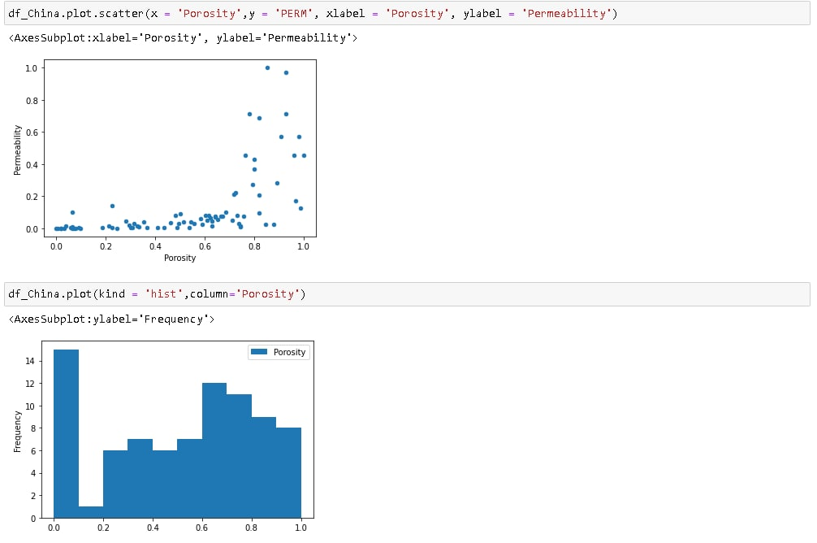 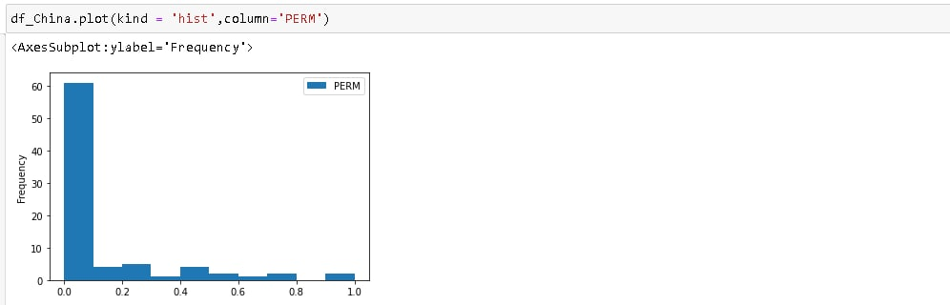

## **B.5: Myanmar**

**Figure 40**

Myanmar Dataset

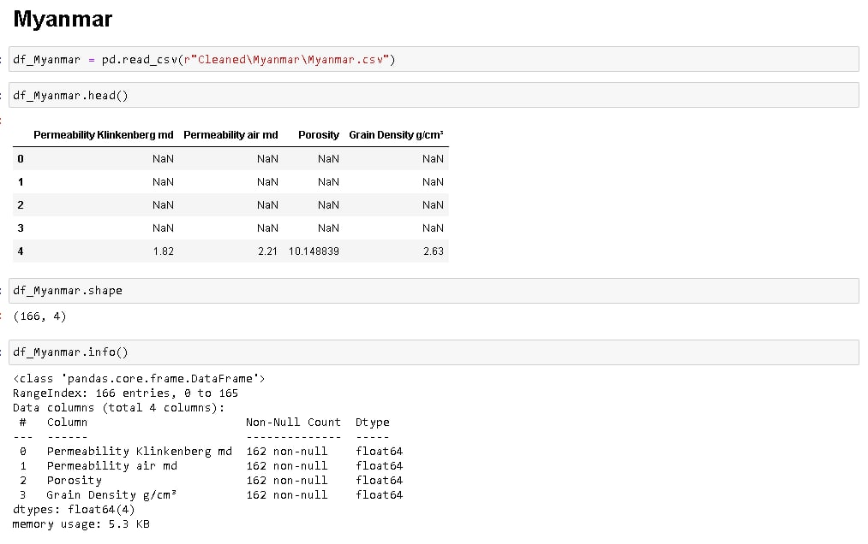

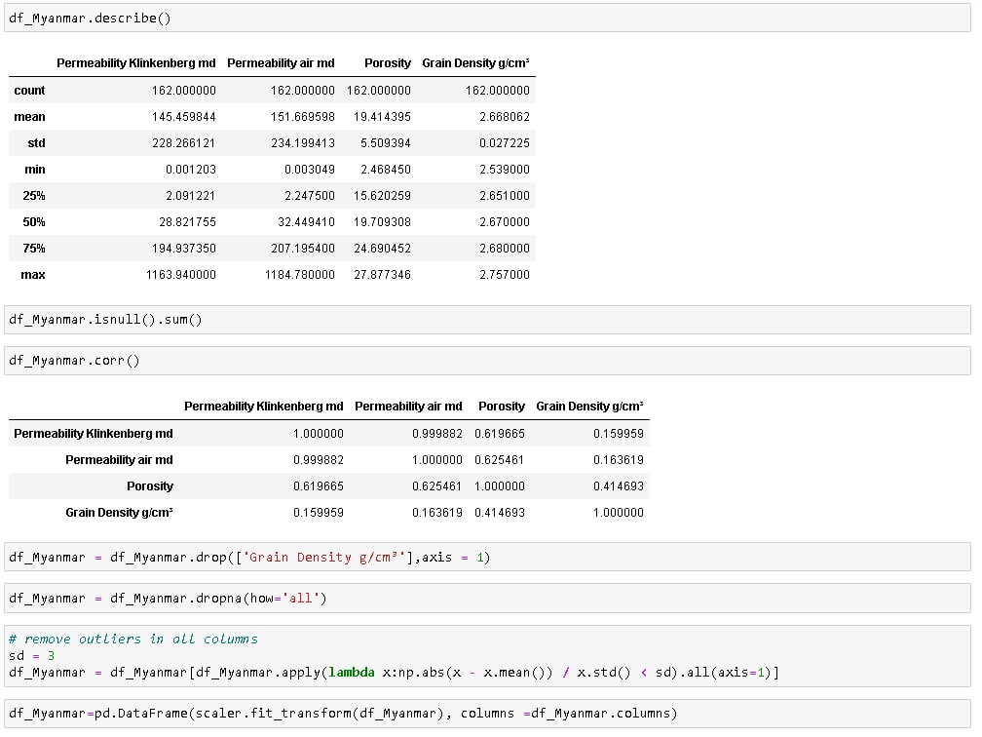 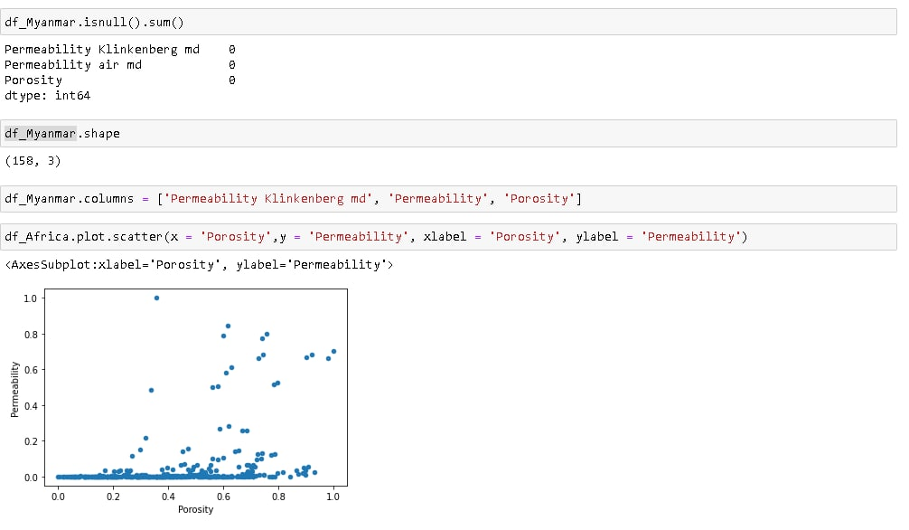 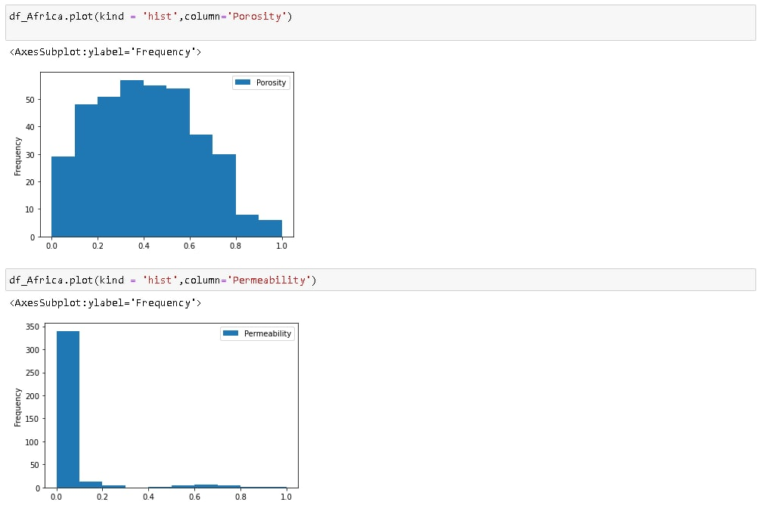

## **B.6: North Sea**

**Figure 41**

North Sea Dataset

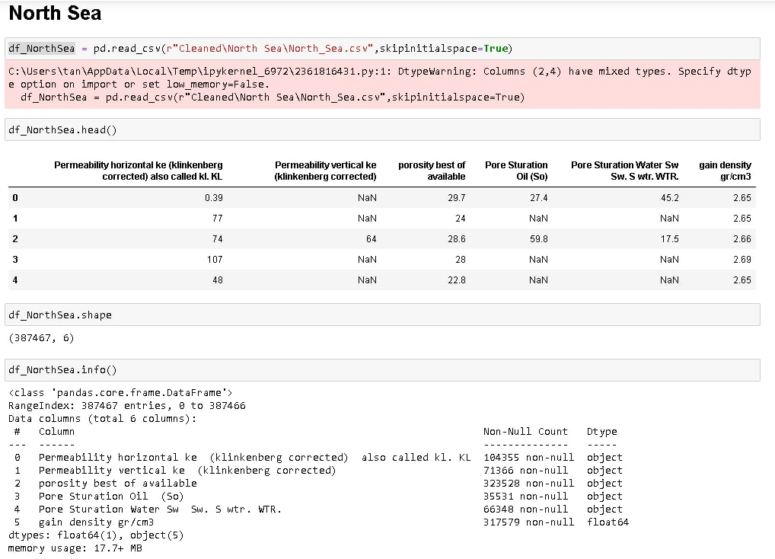

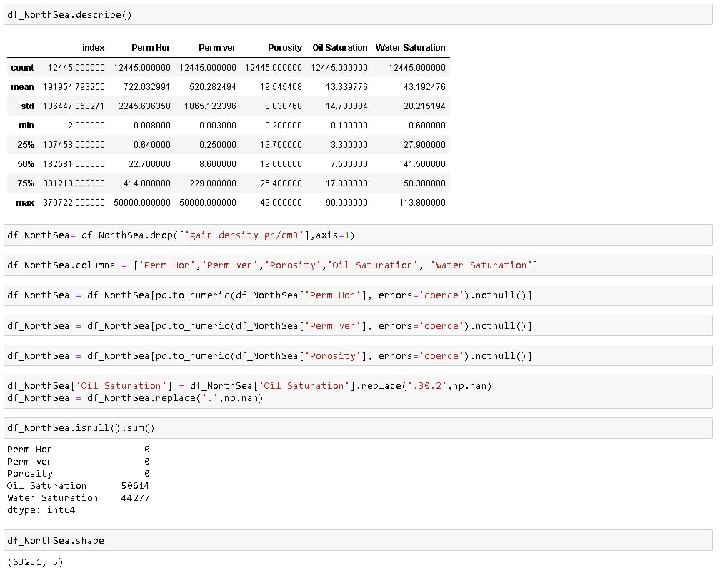

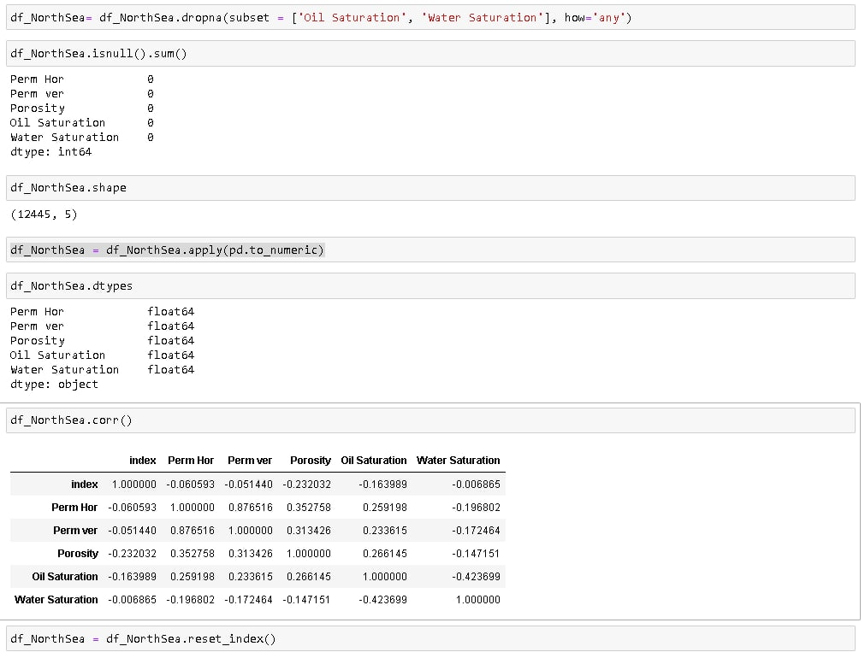

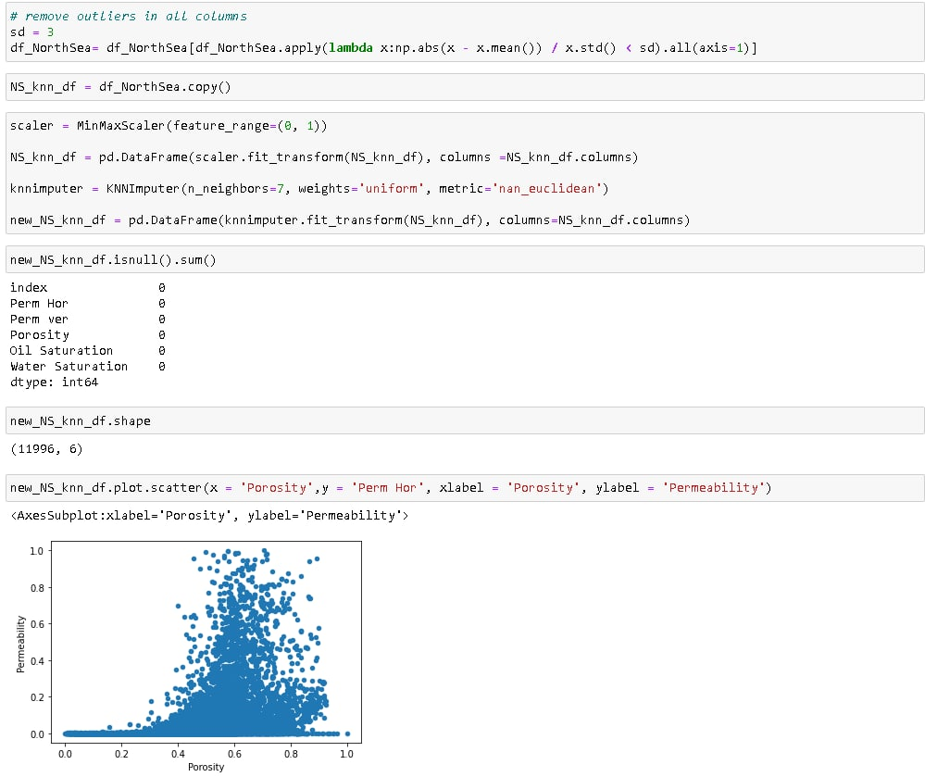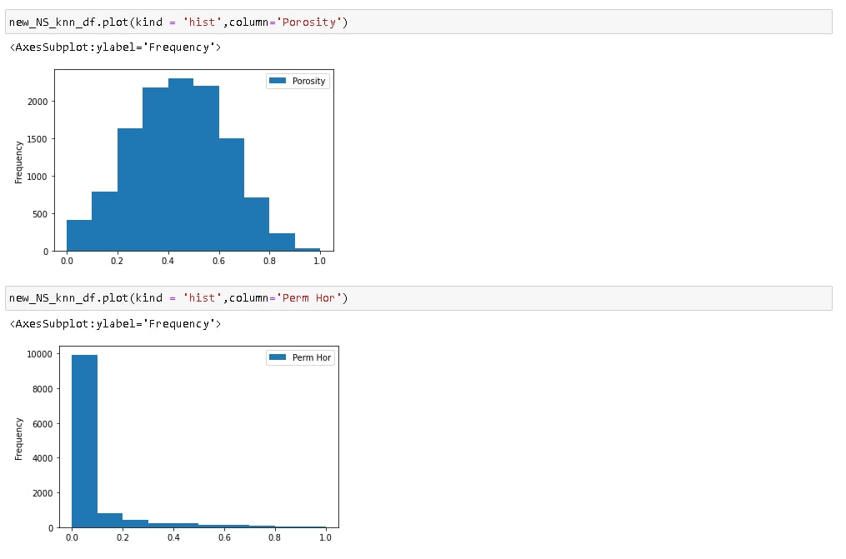

## **B.7: Philippines**

**Figure 42**

Philippines Dataset

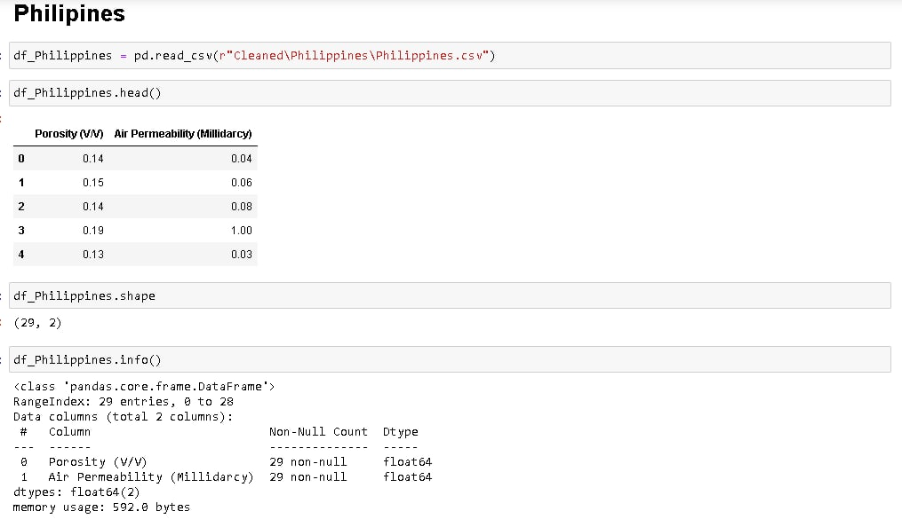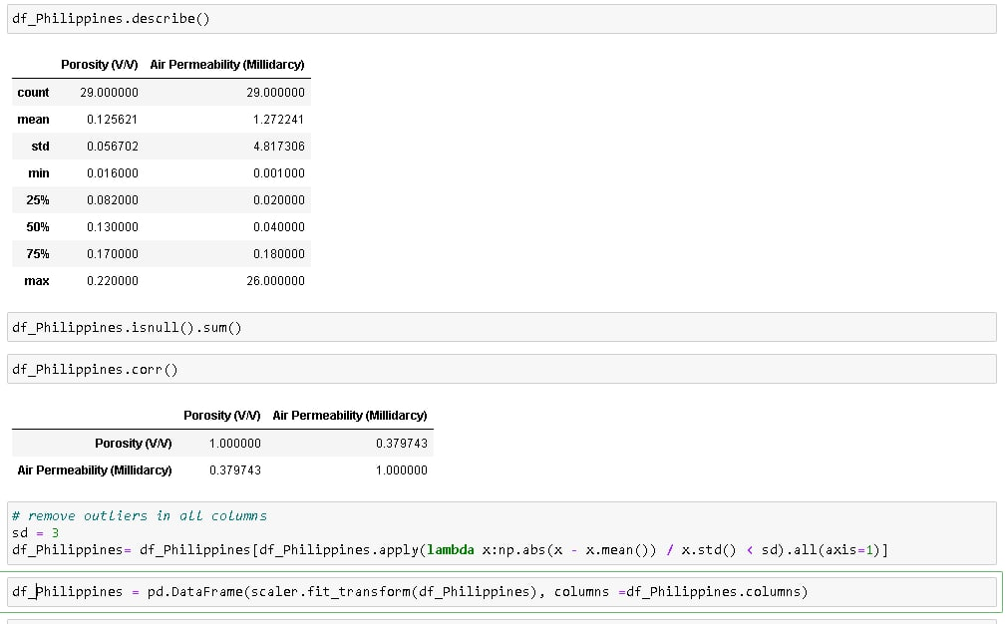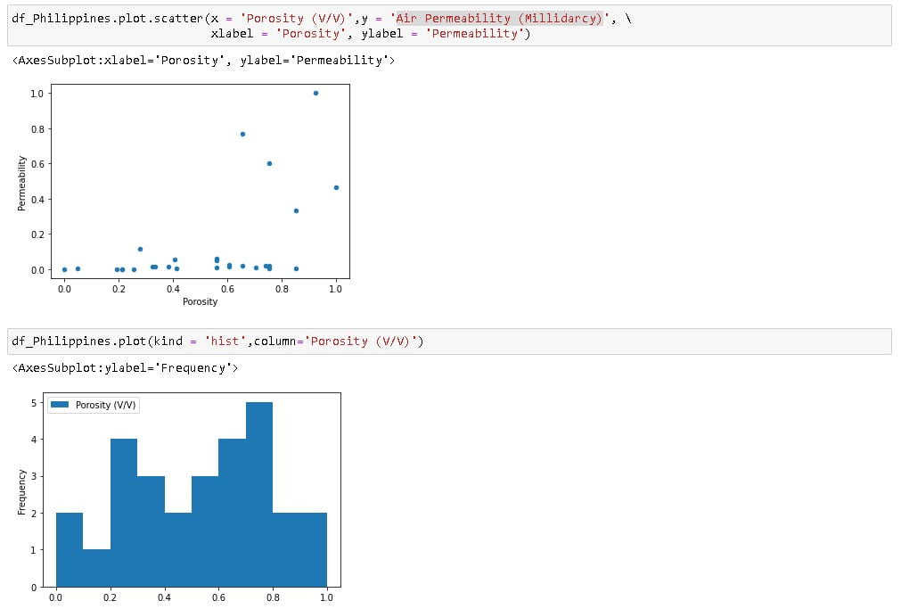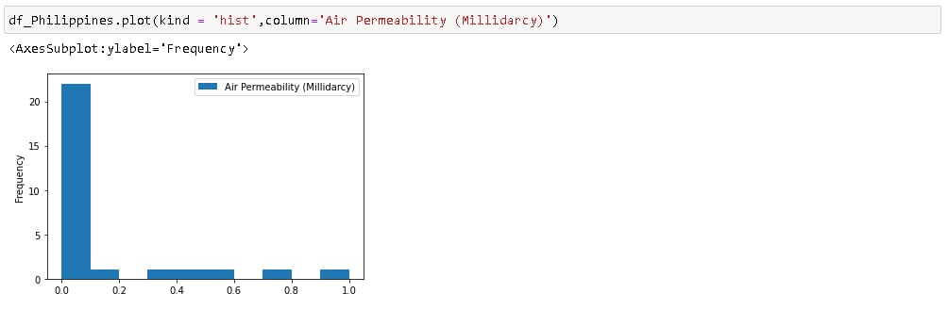

## **B.8: Pakistan**

**Figure 43**

Pakistan Dataset

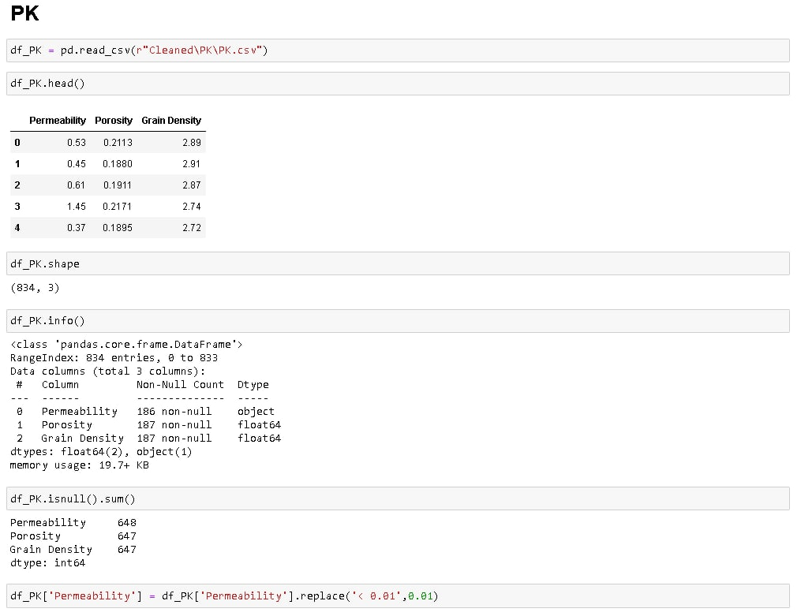

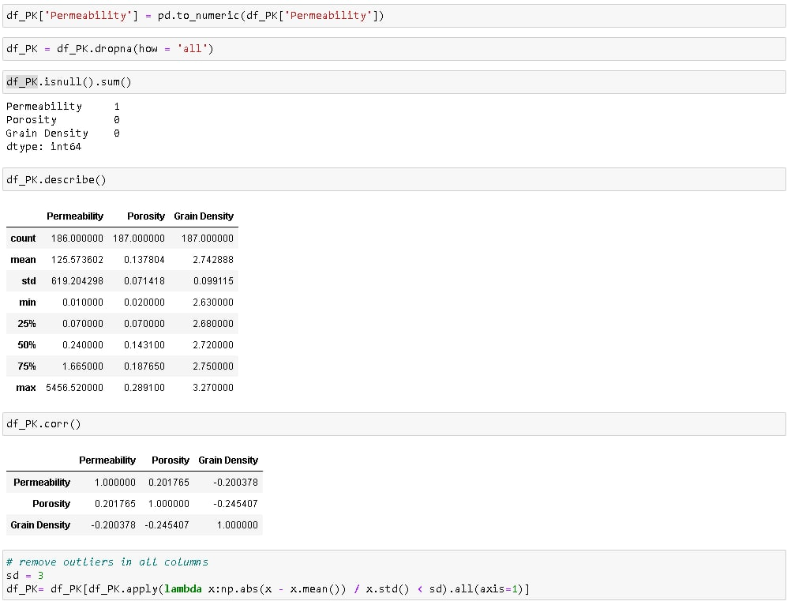

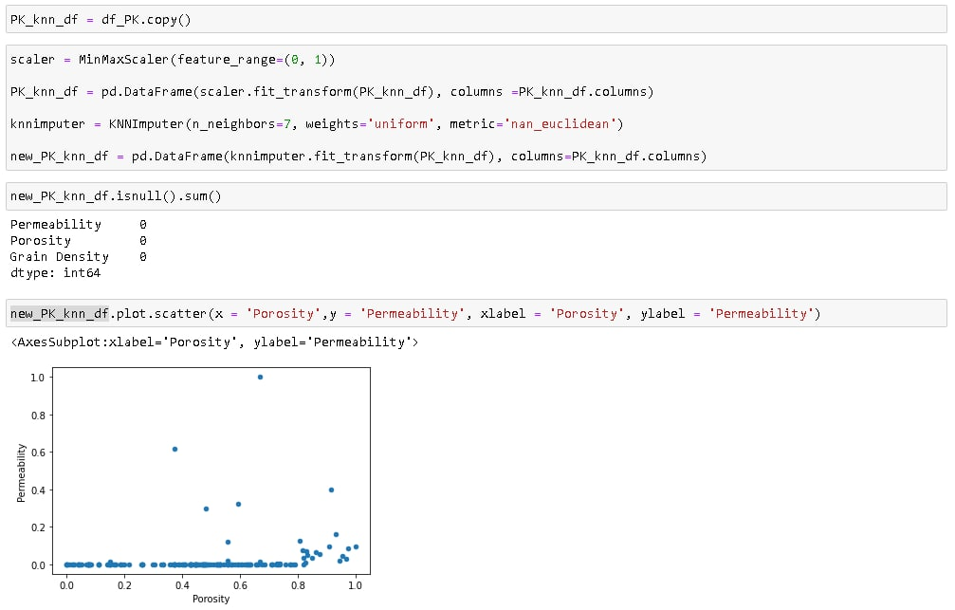

## **B.9: Papua New Guinea**

**Figure 44**

Papua New Guinea Dataset

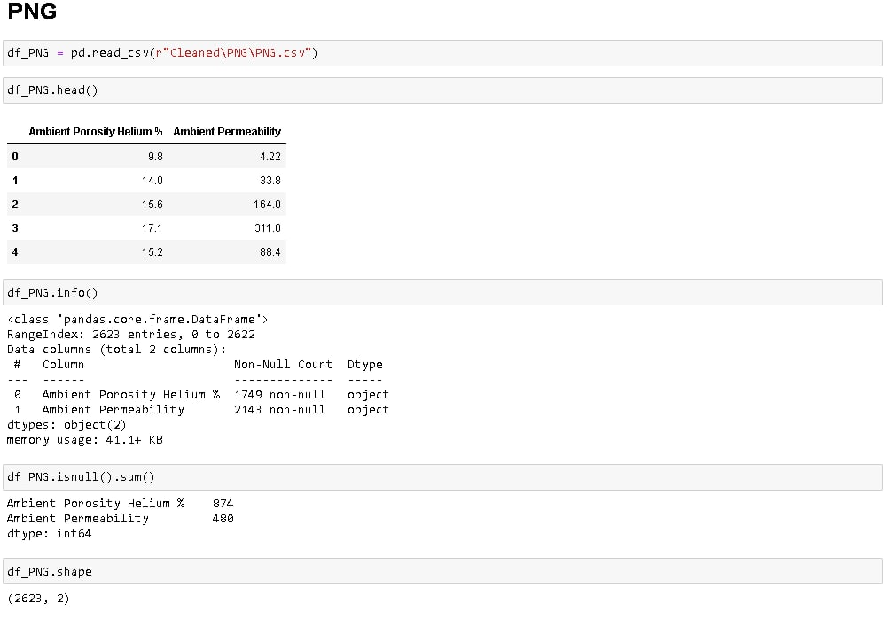

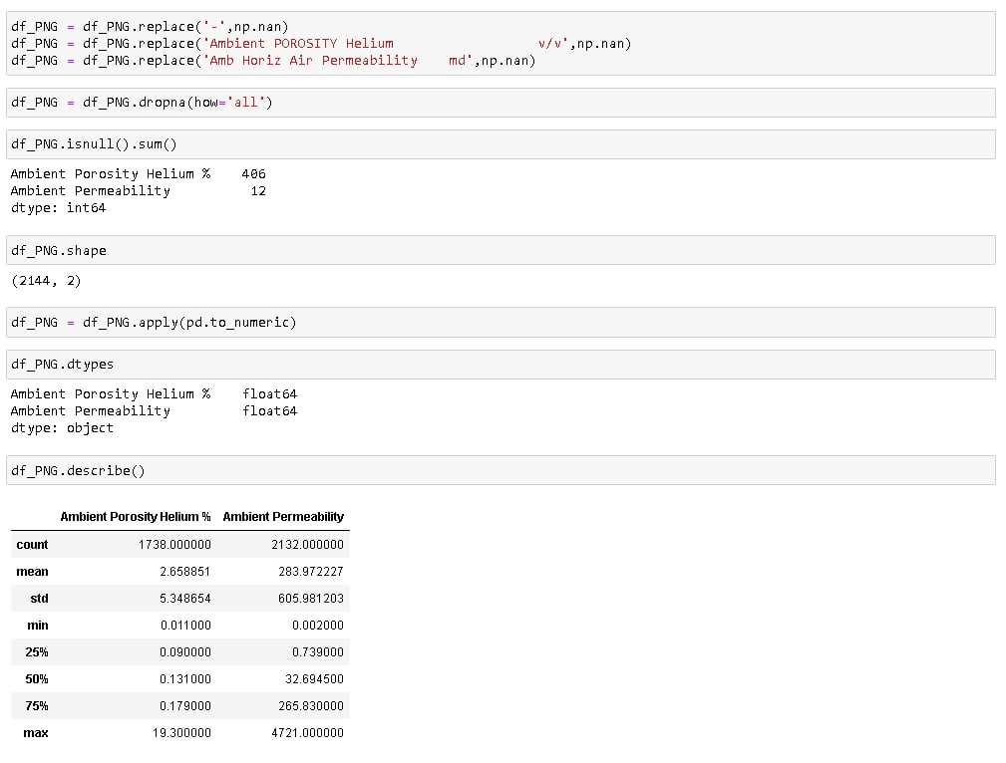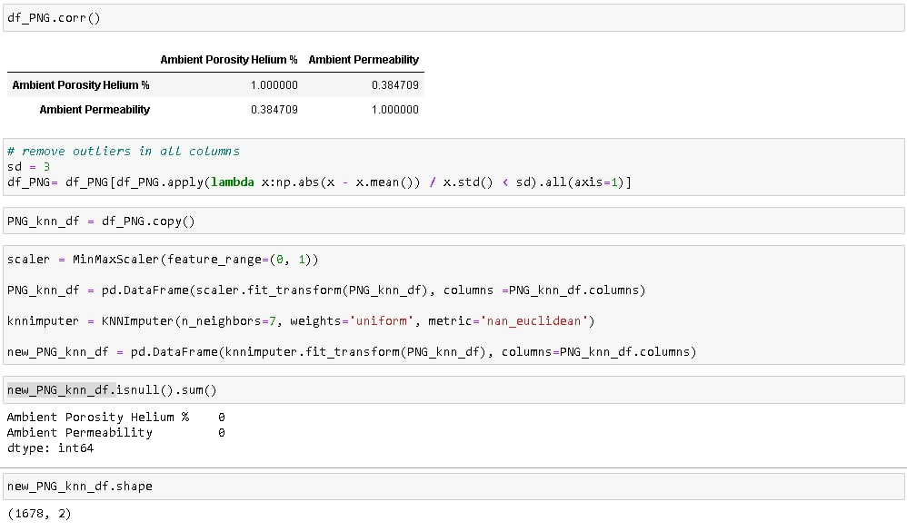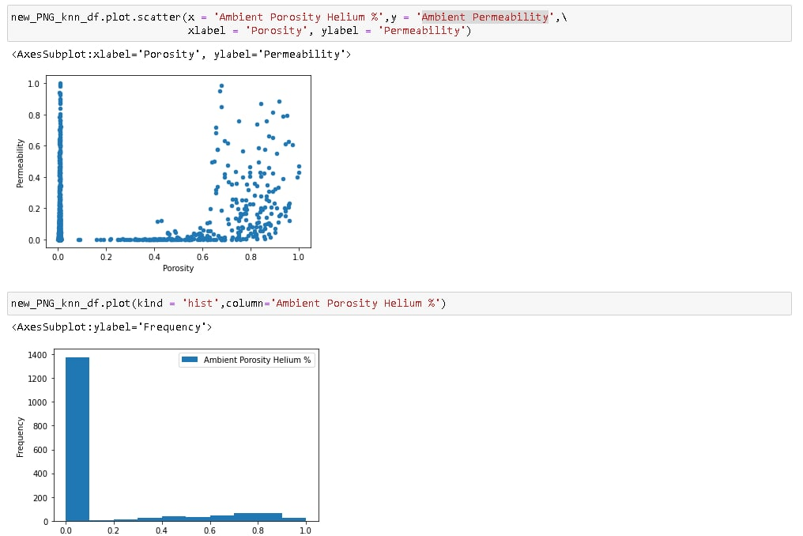

## **B.10: United Kingdom**

**Figure 45**

United Kingdom Dataset

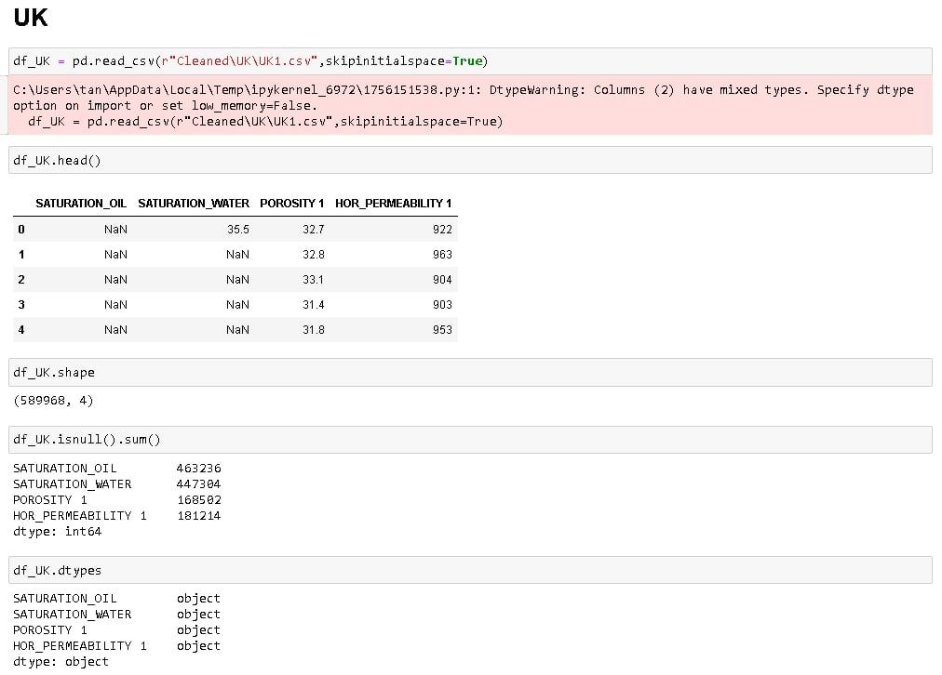

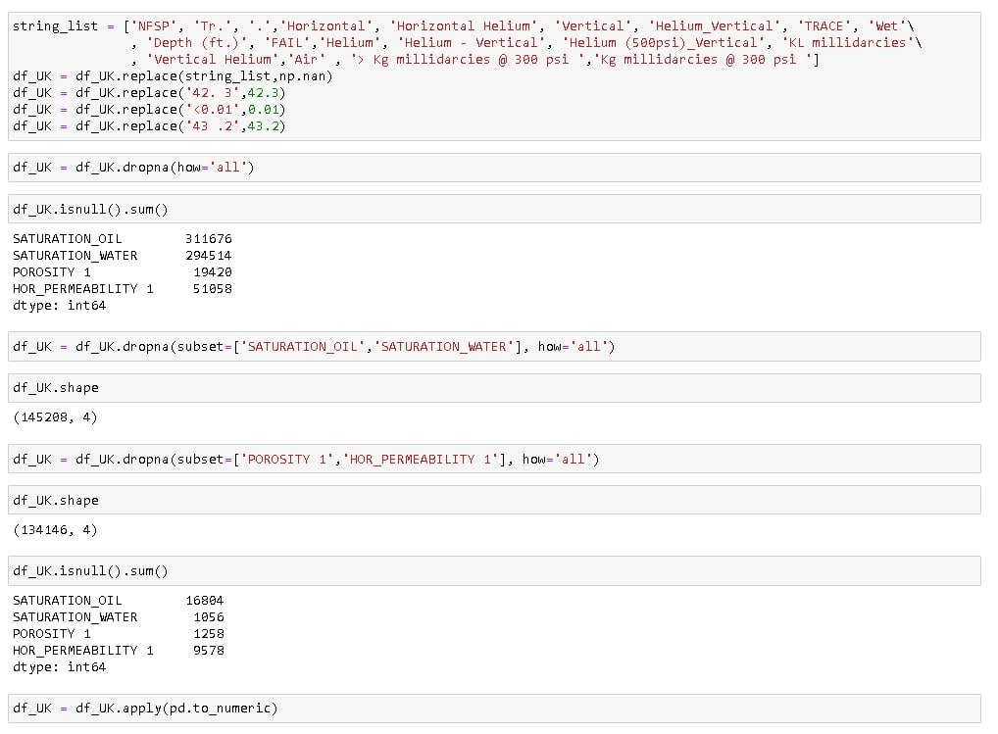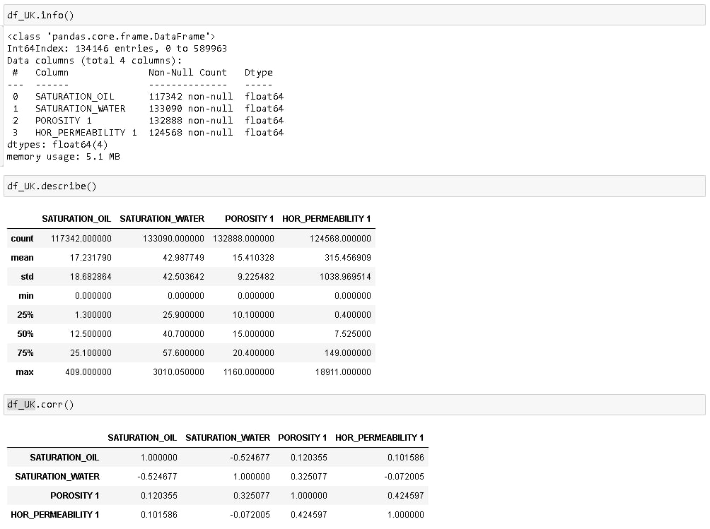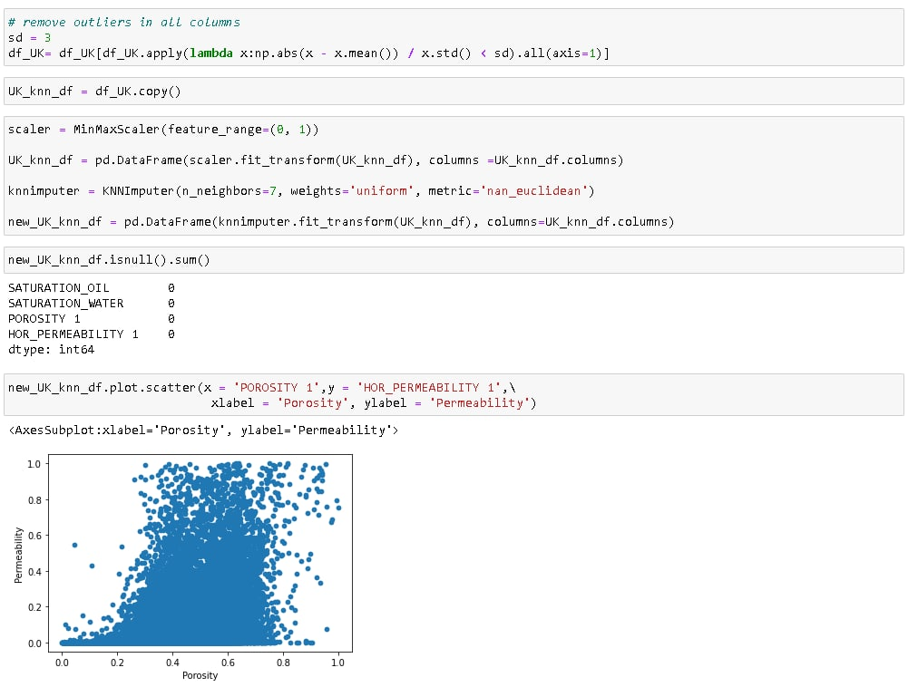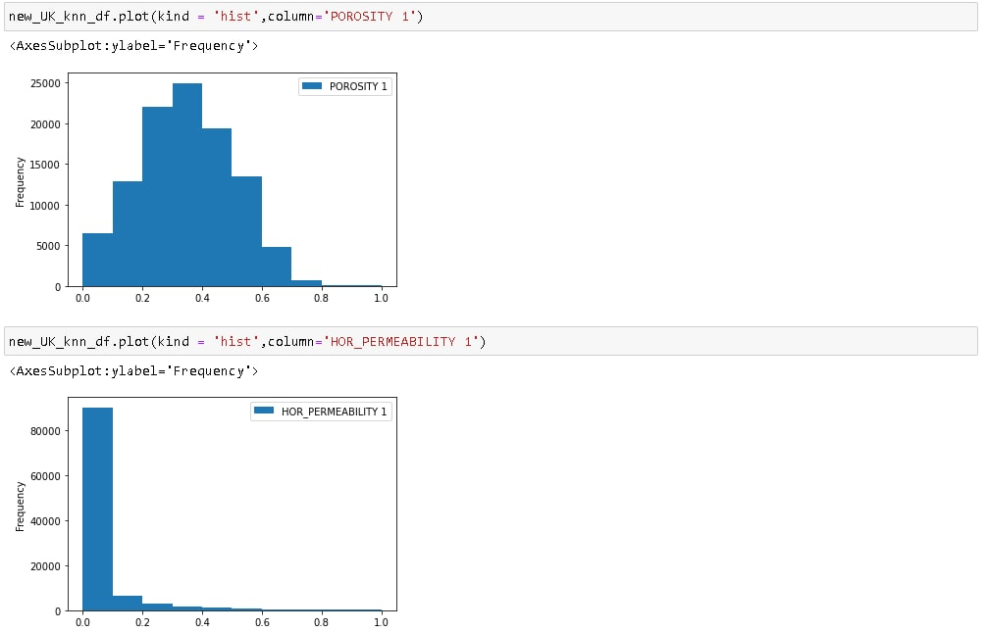

## **B.11: United States of America**

**Figure 46**

United States of America Dataset

